|  |  |  |
| --- | --- | --- |
|  | **.**  **.**  **.**  **.**  **.**  **.**  **.**  **.**  **.**  **.**  **.**  **.**  **.**  **.**  **.**  **.**  **.**  **.**  **.**  **.**  **.**  **.**  **.**  **.**  **.**  **.** | **Application Exercises** |

PART 1

*Note: The exercise for Chapter Extension 1 is basically a tutorial. Therefore, it is presented first, followed by exercises for Chapters 1–3.*

Chapter Extension 1: Learning Excel

1. *Complete Chapter Extension 4, CE1-1, page 347.*

See Figures CE1-1 through CE1-30. (LO: 1, Learning Outcome: Explain how information systems can be used to assist in decision making, AACSB: Information Technology)

1. *Complete Chapter Extension 1, CE1-2, page 348.*
2. *Name and save your workbook using a name of your own choosing.*

No specific answer; a task to be performed.

(LO: 1, Learning Outcome: Explain how information systems can be used to assist in decision making, AACSB: Information Technology)

1. *Enter the value* This is the content of Cell C7 *into cell C7.*

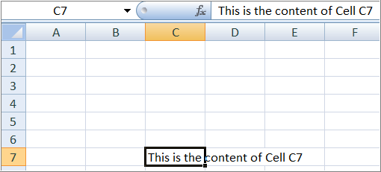

(LO: 3, Learning Outcome: Explain how information systems can be used to assist in decision making, AACSB: Information Technology)

1. *Use F2 to change the value in cell C7 to* This is part of the content of Cell C7*.*

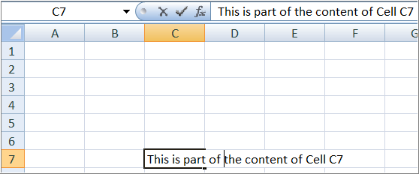

(LO: 3, Learning Outcome: Explain how information systems can be used to assist in decision making, AACSB: Information Technology)

1. *Add the value* January *to cells B2 through B14. Key the data just once.*

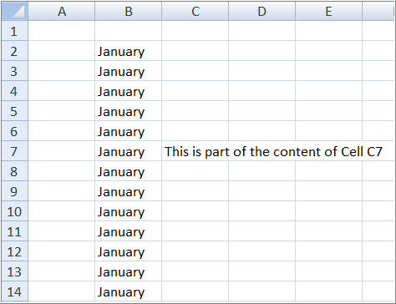

(LO: 3, Learning Outcome: Explain how information systems can be used to assist in decision making, AACSB: Information Technology)

1. *Add the value* January *to cell C2 and the value* February *to cell C3. Highlight both cells C2 and C3 and drag the small black box down to cell C14. Explain what happens.*

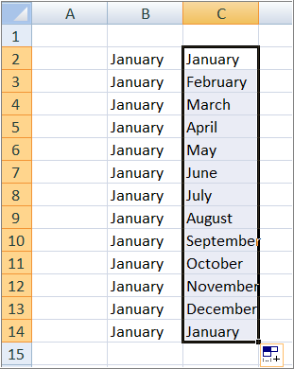

Excel interprets this pattern to display the sequence of month names. (LO: 3, Learning Outcome: Explain how information systems can be used to assist in decision making, AACSB: Information Technology)

1. *Create a list of odd numbers from 1 to 11 in cells C3 through C8. Key only the values 1 and 3.*

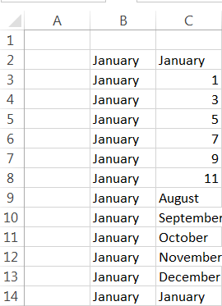

(LO: 3, Learning Outcome: Explain how information systems can be used to assist in decision making, AACSB: Information Technology)

1. *Enter the value* MIS-1 *in cell D2 and the value* MIS-2 *in cell D3. Highlight cells D2 and D3 and drag the small black box down to cell D14. Explain what happens.*

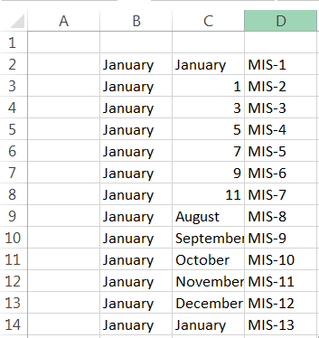

Excel interprets this pattern to increment the numbers in a sequence. (LO: 3, Learning Outcome: Explain how information systems can be used to assist in decision making, AACSB: Information Technology)

1. *Complete Chapter Extension 1, CE1-3, page 351.*
2. *Place the labels* Part Description, Quantity On Hand, Cost, *and* Total Value *in cells B2, C2, D2, and E2, respectively. Center each label in its cell and make the labels bold. (Do this by highlighting the labels and clicking the bold* B *in the* Font *section of the* Home *tab). Make each column large enough to show the entire label after formatting.*

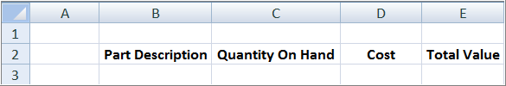

1. *In cells B3, B4, B5, B6, and B7, respectively, enter the following values:*

*This is where one would type the description of Part 1*

*This is where one would type the description of Part 2*

*This is where one would type the description of Part 3*

*This is where one would type the description of Part 4*

*This is where one would type the description of Part 5*

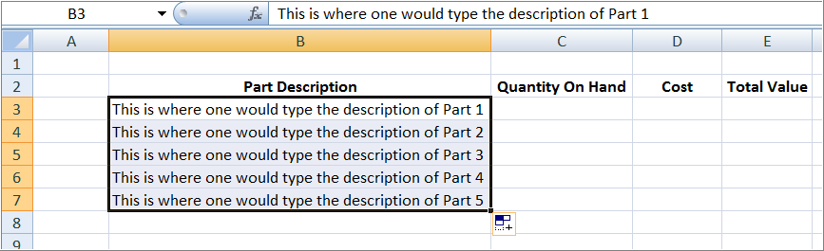

*Enter these values using the fewest possible keystrokes.*

(LO: 3, Learning Outcome: Explain how information systems can be used to assist in decision making, AACSB: Information Technology)

1. *Enter the Quantity On Hand values* 100, 150, 100, 175, *and* 200 *in cells C3 through C7, respectively. Enter these values using the fewest possible keystrokes.*

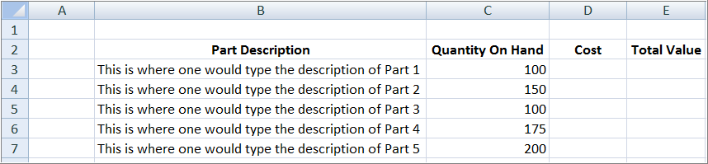

(LO: 3, Learning Outcome: Explain how information systems can be used to assist in decision making, AACSB: Information Technology)

1. *Enter the Cost values* $100, $178, $87, $195, *and* $117 *in cells D3 through D7, respectively. Do not enter the dollar signs. Instead, enter only the numbers and then reformat the cells so that Excel will place the dollar signs.*

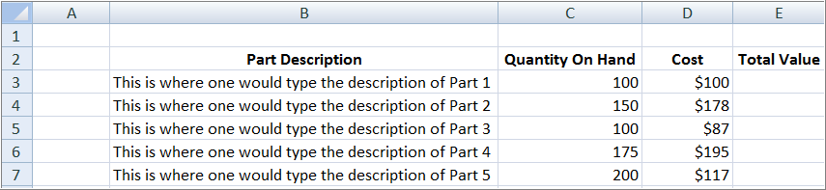

(LO: 5, Learning Outcome: Explain how information systems can be used to assist in decision making, AACSB: Information Technology)

1. *In cell E3, enter a formula that will multiply the Quantity On Hand (C3) by the Cost (D3).*

Entering the formula:

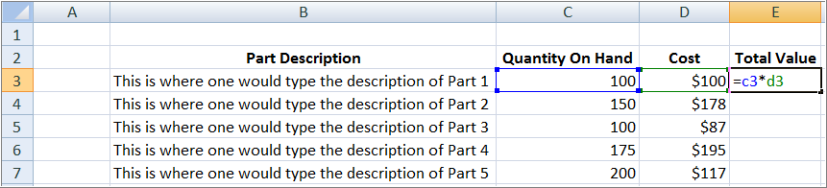

The result of the formula:

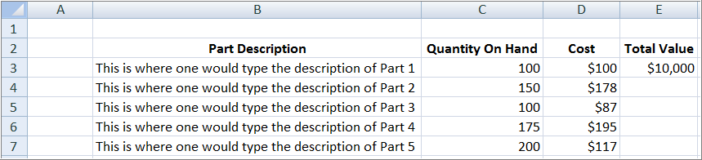

(LO: 6, Learning Outcome: Explain how information systems can be used to assist in decision making, AACSB: Information Technology)

1. *Create the same formula in cells E4 through E7. Use select and copy operations.*

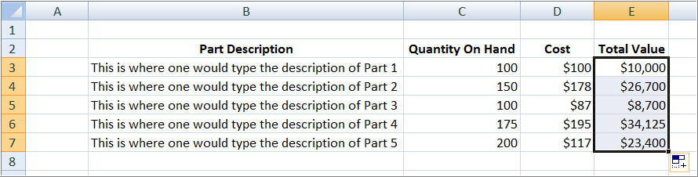

(LO: 6, Learning Outcome: Explain how information systems can be used to assist in decision making, AACSB: Information Technology)

1. *Explain what is magic about the operation in part f.*

When the formula was copied down the column, the row references were automatically adjusted to the row references of the destination cells. (LO: 6, Learning Outcome: Explain how information systems can be used to assist in decision making, AACSB: Information Technology)

1. *Print the result of your activities in parts a–f. Print your document in landscape mode, showing cell boundaries and row and column names.*

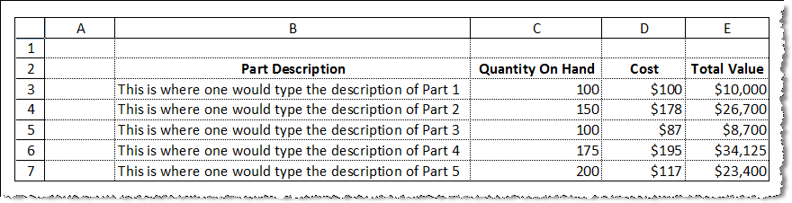

(LO: 7, Learning Outcome: Explain how information systems can be used to assist in decision making, AACSB: Information Technology)

Chapter 1: Quality of Information with Excel

1. *The spreadsheet in Microsoft Excel file* ***Ch01Ex01_E9e.xlsx*** *contains records of employee activity on special projects. Open this workbook and examine the data that you find in the three spreadsheets it contains. Assess the accuracy, relevancy, and sufficiency of this data to the following people and problems.*
2. *You manage the Denver plant, and you want to know how much time your employees are spending on special projects.*

The answer to this question is given directly on the Denver worksheet, so this data is accurate, relevant, and sufficient for the purposes of the Denver plant manager. (LO: 4, Learning Outcome: Explain how information systems can be used to assist in decision making, AACSB: Information Technology)

1. *You manage the Reno plant, and you want to know how much time your employees are spending on special projects.*

The answer to this question is given directly on the Reno worksheet, so this data is accurate, relevant, and sufficient for the purposes of the Reno plant manager. (LO: 4, Learning Outcome: Explain how information systems can be used to assist in decision making, AACSB: Information Technology)

1. *You manage the Quota Computation project in Chicago, and you want to know how much time your employees have spent on that project.*

The project manager will have to manipulate the data on the Chicago worksheet to produce the answer of interest. The worksheet rows could be sorted by project, and then a sum computed of the hours worked for the Quota Computation rows. The data is sufficient, but must be manipulated to produce the relevant result, and because of that manipulation, the accuracy of the result might be questionable. (LO: 4, Learning Outcome: Explain how information systems can be used to assist in decision making, AACSB: Information Technology)

1. *You manage the Quota Computation project for all three plants, and you want to know the total time employees have spent on your project.*

This project manager will have considerable work to do to find the result needed. On each sheet, the worksheet rows will have to be sorted by project, a sum will have to be computed for the Quota Computation project, and then this sum will have to be added to a total for all three plants. The data provided is sufficient to produce the desired result, but its relevancy is questionable because of the amount of effort required to find the answer of interest to the manager, and there is a significant risk of inaccuracy resulting from all the manipulations that are required. (LO: 4, Learning Outcome: Explain how information systems can be used to assist in decision making, AACSB: Information Technology)

1. *You manage the Quota Computation project for all three plants, and you want to know the total labor cost for all employees on that project.*

This information is not available at all, because there is no data regarding labor cost in the workbook. Therefore, although the data provided may be accurate and somewhat relevant, it is not sufficient to produce the desired result. (LO: 4, Learning Outcome: Explain how information systems can be used to assist in decision making, AACSB: Information Technology)

1. *You manage the Quota Computation project for all three plants, and you want to know how the labor-hour total for your project compares to the labor-hour totals for the other special projects.*

This result can be found with some effort. If the manager produced the answer in part d above, then this can be subtracted from the total hours worked on all projects for all three plants to find the total hours worked on all other special projects. The data provided is sufficient to produce the desired result, but its relevancy is questionable because of the amount of effort required to find the answer of interest to the manager, and there is a significant risk of inaccuracy resulting from all the manipulations that are required. (LO: 4, Learning Outcome: Explain how information systems can be used to assist in decision making, AACSB: Information Technology)

1. *What conclusions can you make from this exercise?*

The data in the workbook do provide us with the ability to answer questions about labor hours worked on special projects, so the data is sufficient. As the data is grouped on individual sheets by plant, it becomes more difficult to answer questions that span more than one plant. So, the data’s relevance decreases because we can’t find answers without some work. As more manipulation has to be done to find answers to questions, there is more of a chance of introducing errors in the answers, thus lowering the accuracy of the data. (LO: 4, Learning Outcome: Explain how information systems can be used to assist in decision making, AACSB: Information Technology)

AccessChapter 1: Comparing Information from Excel and Access

1. *The database in the Microsoft Access file* ***Ch01Ex02_E9e.accdb*** *contains the same records of employee activity on special projects as in Application Exercise 1-1. Before going any further, open that database and view the records in the Employee Hours table.*
2. *Eight queries have been created that process this data in different ways. Using the criteria of accuracy, relevancy, and sufficiency, select the one query that is most appropriate for the information requirements in Application Exercise 1-1, parts a–f. If no query meets the need, explain why.*
   * *You manage the Denver plant, and you want to know how much time your employees are spending on special projects.*

The Denver Sum query provides a direct answer to this question. It is accurate, relevant, and sufficient. The Plant Sum query also contains the answer to this question along with answers for the other two plants. (LO: 4, Learning Outcome: Explain how information systems can be used to assist in decision making, AACSB: Information Technology)

* + *You manage the Reno plant, and you want to know how much time your employees are spending on special projects.*

There is no query that answers this question directly. However, the Plant Sum query includes the answer to this question. It is accurate and sufficient, but adds some information that is not relevant (sums for the Denver and Chicago plants). (LO: 4, Learning Outcome: Explain how information systems can be used to assist in decision making, AACSB: Information Technology)

* + *You manage the Quota Computation project in Chicago, and you want to know how much time your employees have spent on that project.*

The Sorted Query 1 query can be used to find the answer to this question. This query lists the hours worked by employees in the Chicago plant on the Quota Computation project. These hours can be manually added to find the total hours spent on the Quota Computation project by Chicago plant employees. The data is sufficient, but must be manipulated to produce the relevant result, and because of that manipulation, the accuracy of the result might be questionable. Because there is unneeded information in the query, the data is more than sufficient to answer the question. (LO: 4, Learning Outcome: Explain how information systems can be used to assist in decision making, AACSB: Information Technology)

* + *You manage the Quota Computation project for all three plants, and you want to know the total time your employees have spent on your project.*

None of the queries provide a direct answer for this question. Sorted Query 1, Sorted Query 2, or Sorted Query 3 can be used to compute the answer, but the manager must add specific individual rows in the query to compute the result. The data is sufficient, but must be manipulated to produce the relevant result, and because of that manipulation, the accuracy of the result might be questionable. Because there is unneeded information in the query, the data is more than sufficient to answer the question. (LO: 4, Learning Outcome: Explain how information systems can be used to assist in decision making, AACSB: Information Technology)

* + *You manage the Quota Computation project for all three plants, and you want to know the total labor cost for all employees on your project.*

This information is not available at all, as there is no data regarding labor cost in the database. Therefore, although the data provided may be accurate and somewhat relevant, it is not sufficient to produce the desired result. (LO: 4, Learning Outcome: Explain how information systems can be used to assist in decision making, AACSB: Information Technology)

* + *You manage the Quota Computation project for all three plants, and you want to know how the labor hour total for that project compares to the labor hour totals for the other special projects.*

This result can be found with some effort. If the manager produced the total hours worked in all plants on the Quota Computation project, then this can be subtracted from the total hours worked on all projects for all three plants to find the total hours worked on all other special projects (found by adding the three rows in the Plant Sum query). The data provided is sufficient to produce the desired result, but its relevancy is questionable because of the amount of effort required to find the answer of interest to the manager, and there is a significant risk of inaccuracy resulting from all the manipulations that are required. (LO: 4, Learning Outcome: Explain how information systems can be used to assist in decision making, AACSB: Information Technology)

1. *What conclusions can you make from this exercise?*

Queries can be formulated to answer specific questions quickly and easily, but should be constructed to produce the exact answer to the question, rather than expecting the user to do additional manual computations to find the necessary answer. In addition, queries should be given meaningful names so that the user can easily determine which to use to answer questions. (LO: 4, Learning Outcome: Explain how information systems can be used to assist in decision making, AACSB: Information Technology)

1. *Comparing your experiences on these two projects, what are the advantages and disadvantages of spreadsheets and databases?*

Queries in databases can be constructed to produce specific answers, and are easy to use. When a query does not exist to give a needed result, finding the result through manual computation is harder than when using a spreadsheet because you don’t have access to the spreadsheet’s computational capabilities. (LO: 4, Learning Outcome: Explain how information systems can be used to assist in decision making, AACSB: Information Technology)

**Chapter 1: IS Job Statistics

1. *In this project, you will look at statistics related to information systems jobs. For several years, the demand for IT workers has been increasing. So have average annual wages for IT workers. Projections for future job demand and salary growth are also well above average.*

*The sites below allow you to search by job code (e.g., 15-1071) or by job title. The data is aggregated by state, but you can look up statistics for your individual city through the Department of Labor’s (DOL’s) Web site (www.dol.gov/dol/location.htm). The DOL site links to your local state government’s Web page.*

*This project gives you a realistic look at expected IT salaries. You can also use the sites from this project to look at wage data for other occupations (i.e., jobs in your major).*

***(1)*** *Go to O*NET at* http://online.onetcenter.org/.

***(2)*** *Type “network administrator” into the Occupation Quick Search in the top right of the screen.*

***(3)*** *Press Enter.*

***(4)*** *Click on the first link.*

***(5)*** *Click on* Wages & Employment*.*

***(6)*** *Take a screenshot. (You can take a screenshot by pressing Alt+Print Screen.)*

***(7)*** *Select your state from the State Wages drop-down box.*

***(8)*** *Click Go.*

***(9)*** *Click on the* Yearly Wage Chart*.*

***(10)*** *Take a screenshot.*

***(11)*** *Go to the U.S. Bureau of Labor Statistics at* www.bls.gov/OES/.

***(12)*** *Click on* Subjects *and then* Pay & Benefits*.*

***(13)*** *Click* Wages by Area and Occupation*.*

***(14)*** *Click the link labeled* By State *under the Wage Data by State section.*

***(15)*** *Click on a state. (Choose the state you want to work in after you graduate.)*

***(16)*** *Click on the link labeled* 15-0000 Computer and Mathematical Occupations*.*

***(17)*** *Take a screenshot.*

***(18)*** *Click on the link labeled* Network and Computer Systems Administrators*. (Note the mean annual wage.)*

***(19)*** *Click on the link labeled* Geographic profile for this occupation*. (This will show you the states with the highest concentration of workers in this job category. It will also show you the states that have the highest annual salaries for this job category.)*

***(20)*** *Take a screenshot.*

***a.*** *Could you find statistics for employment by city within your state?* Hint*: Visit the U.S. Department of Labor at* www.dol.gov/dol/location.htm*.*

***b.*** *Is the demand for IT jobs (networking administrators) projected to increase more than the national average? Why or why not?*

***c.*** *Is the average salary for IT workers (networking administrators) projected to increase more than the national average? Why or why not?*

***d.*** *Why do you think the projections for job demand and salary increase for IT workers are so high?*

Since this is an experiential exercise, no specific solution is provided. Student answers will vary. (LO: 3, Learning Outcome: Explain how information systems can be used to assist in decision making, AACSB: Information Technology)

Chapter 2: Use Excel to Compute Inventory Value

1. *Figure AE-1 shows an Excel spreadsheet that the resort bicycle rental business uses to value and analyze its bicycle inventory. Examine Figure AE-1 to understand the meaning of the data. Now use Excel to create a similar spreadsheet. Note the following:*

* *The top heading is in 20-point Calibri font. It is centered in the spreadsheet. Cells A1 through H1 have been merged.*
* *The second heading, Bicycle Inventory Valuation*, *is in 18-point Calibri, italics. It is centered in cells A2 through H2, which have been merged.*
* *The column headings are set in 11-point Calibri, bold. They are centered in their cells, and the text wraps in the cells.*

## Make the first two rows of your spreadsheet similar to that in Figure AE-1. Choose your own colors for background and type, however.

## Place the current date so that it is centered in cells C3, D3, and E3, which must be merged.

## Outline the cells as shown in Figure AE-1.

## Figure AE-1 uses the following formulas:

***Cost of Current Inventory = Bike Cost × Number on Hand***

***Revenue per Bike = Total Rental Revenue / Number on Hand***

***Revenue as a Percent = Total Rental Revenue /***

***Cost of Current Inventory***

*Please use these formulas in your spreadsheet, as shown in Figure AE-1.*

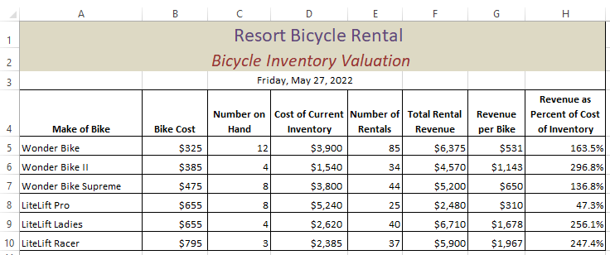

(LO: 6, Learning Outcome: Explain how information systems can be used to assist in decision making, AACSB: Information Technology)

## Format the cells in the columns, as shown.

## 

(LO: 6, Learning Outcome: Explain how information systems can be used to assist in decision making, AACSB: Information Technology)

## Give three examples of decisions that management of the bike rental agency might make from this data.

A spreadsheet such as this can help identify underutilized bikes based on the number of rentals. The LiteLift Pro and the WonderBike II have a relatively low number of rentals compared to the other models. The manager should evaluate why these models are not rented as often as others. Is it the rental price or something about the models themselves that have limited appeal?

The revenue per bike can identify models that are very productive (e.g., LiteLift Racer). Management might want to purchase more highly productive models.

Revenue as a percent of cost of inventory shows management which models are good investments. The LiteLift Ladies and LiteLift Racer were expensive models, but are generating a good return. Buying more of these models might be worth considering. (LO: 6, Learning Outcome: Explain how information systems can be used to assist in decision making, AACSB: Information Technology)

## What other calculation could you make from this data that would be useful to the bike rental management? Create a second version of this spreadsheet in your worksheet document that has this calculation.

The modified spreadsheet below has added a column for the number of rentals per bike. This information shows the popularity of the models. Management should consider buying more of the popular models and investigate why some models don’t seem to be popular. (LO: 6, Learning Outcome: Explain how information systems can be used to assist in decision making, AACSB: Information Technology)

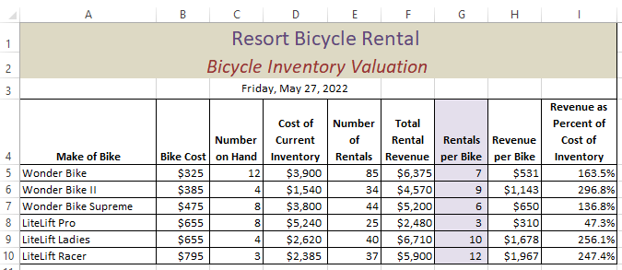

Chapter 2: Use PowerPoint to Diagram Business Process

1. *PowerPoint file* ***Ch02Ex01_E9e.pptx*** *contains a diagram similar to Figure 2-8 as well as a collection of spare shapes. Using these shapes, create a business process for Ship Order to Customers activity. Use your own knowledge and expertise to do this. Assume that the inputs to the activity are the Customer Order and Items as well as a list of items from the Receive Goods Place in Inventory activity.*

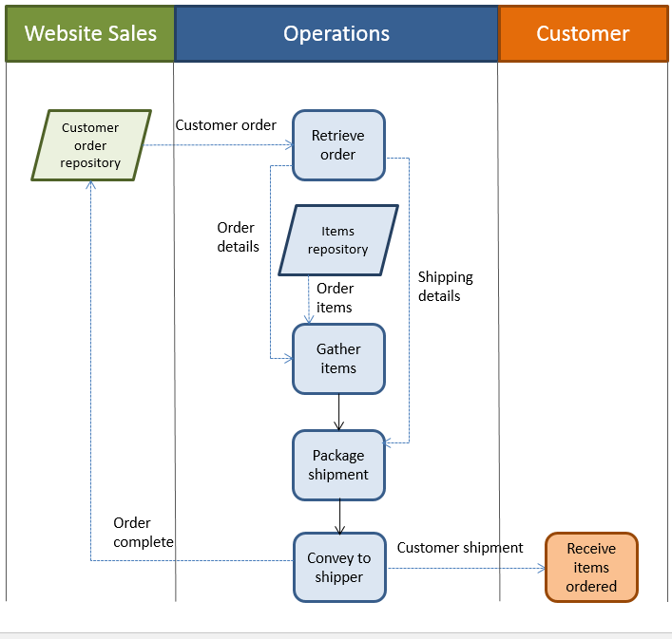

(LO: 2, Learning Outcome: Discuss the role of information systems in supporting business processes, AACSB: Information Technology)

**Chapter 3: Analyzing Revenue Projections

1. *Suppose you work for the bicycle parts distributor mentioned in Q3-2 of Chapter 3. The team was investigating the possibility of selling 3D printable plans for bike parts rather than the parts themselves. The team needs to identify qualifying parts and compute how much revenue potential those parts represent. Download the Access file* ***Ch03Ex01_E9e.accdb,*** *which contains the data extract the team used.*
2. *Suppose Desert Gear Supply decides not to release its 3D design files at any price. Remove parts provided by it from consideration and repeat the data analysis in Chapter 3.*

Modified Figure 3-4 – Orders and Parts View without Desert Gear Supply

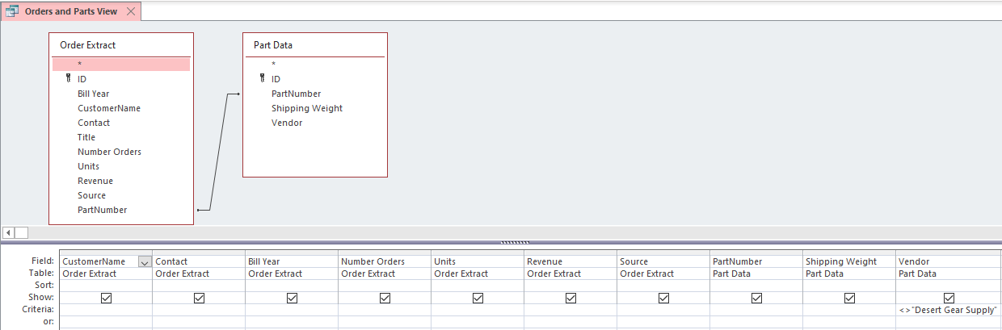

Modified Figure 3-5 Customer Summary without Desert Gear Supply

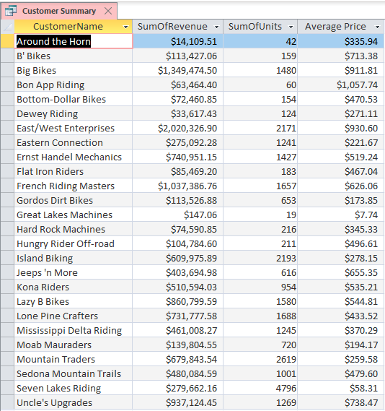

Selection of Big Customers without Desert Gear Supply

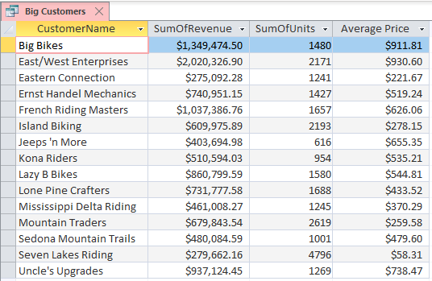

Modified Figure 3-6 Qualifying Parts without Desert Gear Supply

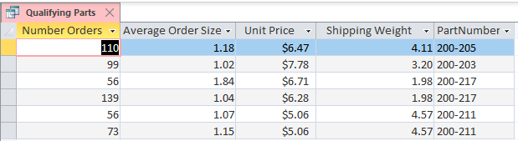

Modified Figure 3-7 Revenue Potential without Desert Gear Supply

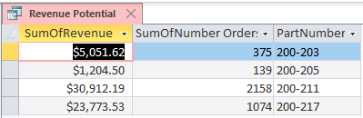

(LO: 2, Learning Outcome: Explain how information systems can be used to assist in decision making, AACSB: Information Technology)

1. *The team decides, in light of the absence of Desert Gear Supply’s part designs, to repeat their analysis with different criteria as follows:*

* *Large customers are those who have ordered more than 900 parts.*
* *Frequent purchases occur at least 25 times per year.*
* *Small quantities have an average order size of 3 or less.*
* *Inexpensive parts cost less than $75.*
* *Shipping weight is less than 4 pounds.*

*Repeat the data analysis in Chapter 3.*

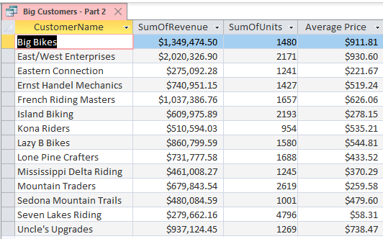

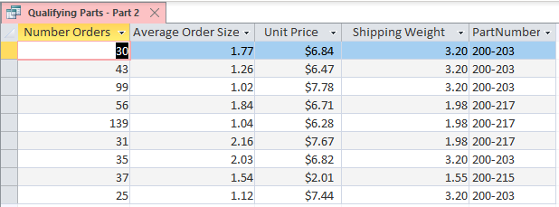

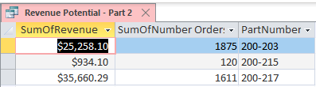

(LO: 2, Learning Outcome: Explain how information systems can be used to assist in decision making, AACSB: Information Technology)

1. *How does the second set of criteria change the results?*

The revenue potential is reduced. Part Number 200-211 is excluded from the results under these assumptions. This part number has a revenue potential of $30,912.19, so the potential value of the sale of 3D parts designs is diminished even more than under the original assumptions.

(LO: 2, Learning Outcome: Explain how information systems can be used to assist in decision making, AACSB: Information Technology)

1. *What recommendations would you make in light of your analysis?*

Based on these analyses, it does not appear that the sale of 3D printing part designs will be a venture worth pursuing. The revenue potential is too small.

(LO: 2, Learning Outcome: Explain how information systems can be used to assist in decision making, AACSB: Information Technology)

**Chapter Extension 2: Using an AI Application

*CE2-1. Microsoft Fetch! is an AI application that is designed to automatically identify dog breeds. Identifying dog breeds is difficult because there are many dog breeds with similar traits. Fetch! analyzes numerous facial traits to try to identify the correct dog breed. It turns out to be amazingly accurate. The fun part is when you upload a picture of yourself and see which dog breed you most closely match. Another AI-driven Microsoft application (*www.how-old.net*) guesses how old you look based on your picture. We will consider both of these applications in this exercise.*

*a. Go to* www.what-dog.net*. (Microsoft Fetch! runs the application on this site.)*

*b. Click* Use your own photo*.*

*c. Select a picture of yourself from your computer.*

*d. Take a screenshot of the results. (One of the authors, Boyle, was identified as an Irish Setter. The other author, Kroenke, was identified as a Boerboel.)*

*e. Go to* [www.how-old.net](http://www.how-old.net)*.*

*f. Click* Use your own photo*.*

*g. Select a picture of yourself from your computer.*

*h. Take a screenshot of the results.*

No particular response; tasks to be performed by students. (LO: 6, Learning Outcome: Explain how information systems can be used to assist in decision making, AACSB: Information Technology)

*i. Explain how AI applications like these could be useful beyond identifying dog breeds and ages.*

Student responses to this question may vary. In general, these examples demonstrate the pattern recognition process used in AI computer vision applications for things such as facial recognition. (LO: 6, Learning Outcome: Explain how information systems can be used to assist in decision making, AACSB: Information Technology)

*j. How could this type of AI-driven vision system be commercialized (i.e., be used to make money)?*

Student responses to this question may vary. A current application of this technology is the use of facial recognition as a biometric access control for smartphones. (LO: 6, Learning Outcome: Explain how information systems can be used to assist in decision making, AACSB: Information Technology)

Chapter Extension 3: Make Your Own Market-Basket Analysis with Access

1. *It is surprisingly easy to create a market-basket report using table data in Access. To do so, however, you will need to enter SQL expressions into the Access query builder. Here, you can just copy SQL statements to type them in. If you take a database class, you will learn how to code SQL statements like those you will use here.*

*a. Create an Access database with a table named* Order_Data *having columns* OrderNumber, ItemName*, and* Quantity*, with data types Number (*LongInteger*), Short Text (*50*), and Number* (LongInteger), *respectively. Define the key as the composite* (OrderNumber, ItemName). (You can do this in the table designer by highlighting both columns and clicking the Primary Key icon.)

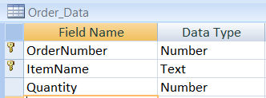

*b. Import the data from the Excel file* ***CE3Ex01_E9e.xlsx*** *into the* Order_Data *table.*

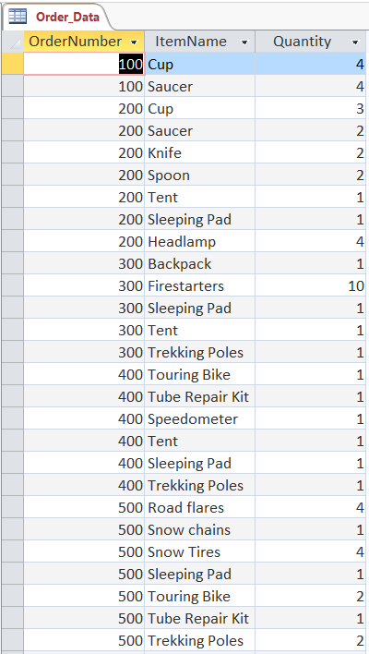

*c. Now, to perform the market basket analysis, you will need to enter several SQL statements into Access. To do so, click the* CREATE/QueryDesign*. Click* Close *when the Show Table dialog box appears. Right-click in the gray section above the grid in the* Select Query *window. Select* SQL View*. Enter the following expression exactly as it appears here:*

SELECT T1.ItemName as FirstItem,

T2.ItemName as SecondItem

FROM Order_Data T1, Order_Data T2

WHERE T1.OrderNumber =

T2.OrderNumber

AND T1.ItemName <> T2.ItemName;

*Click the red exclamation point in the toolbar to run the query. Correct any typing mistakes and, once it works, save the query using the name* TwoItemBasket*.*

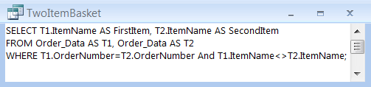

|  |  |  |  |  |
| --- | --- | --- | --- | --- |
|  |  | |  | |
|  | |  | |

*d. Now enter a second SQL statement. Again, click* CREATE/QueryDesign*. Click* Close *when the Show Table dialog box appears. Right-click in the gray section above the grid in the* Select Query *window.*

*Select* SQL View*. Enter the following expression exactly as it appears here:*

SELECT TwoItemBasket.FirstItem,

TwoItemBasket.SecondItem,

Count(*) AS SupportCount

FROM TwoItemBasket

GROUP BY TwoItemBasket.FirstItem,

TwoItemBasket.SecondItem;

*Correct any typing mistakes and, once it works, save the query using the name* SupportCount.

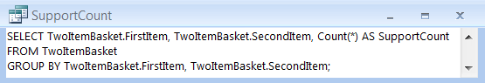

|  |  |
| --- | --- |
|  |  |

|  |  |
| --- | --- |
|  |  |

*e. Examine the results of the second query, and verify that the two query statements have correctly calculated the number of times that two items have appeared together. Explain further calculations you need to make to compute support.*

To compute support, we need to determine the number of times that two items are purchased together out of all the purchase transactions. This will produce the probability of those two items being purchased together. (LO: 4, Learning Outcome: Compare and contrast different business intelligence systems, AACSB: Information Technology)

*f. Explain the calculations you need to make to compute lift. Although you can make those calculations using SQL, you need more SQL knowledge to do it, and we will skip that here.*

Lift is calculated by dividing the probability of Item A being purchased given that Item B is purchased (confidence) by the probability that Item A is purchased. Confidence is computed by dividing the number of times Items A and B were purchased together by the number of times Item A was purchased. (LO: 4, Learning Outcome: Compare and contrast different business intelligence systems, AACSB: Information Technology)

*g. Explain, in your own words, what the query in part c seems to be doing. What does the query in part d seem to be doing? Again, you will need to take a database class to learn how to code such expressions, but this exercise should give you a sense of the kinds of calculations that are possible with SQL.*

## The query in part c is creating a table of records that consist of every pairing of items in an order. So, for example, order 100 in our data consisted of a cup and saucer, so that produces two records in the market basket—cup and saucer and saucer and cup. The second query adds a count column for each record in the market-basket table. (LO: 4, Learning Outcome: Compare and contrast different business intelligence systems, AACSB: Information Technology)

Chapter Extension 4: Reporting with Access

1. *In this exercise, you’ll have an opportunity to practice creating reports in Access using the data shown in Figure CE4-1.*
2. *Open Access, create a new database, and import the data in the text file* ***CE4Ex01_E9e****.****txt****. Notice that the data includes an identifier; the four fields in Figure CE4-1; and a sixth field, called Quarter that represents the calendar quarter in which the sale was made.*

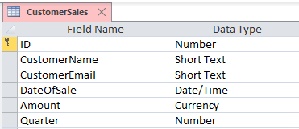

1. *Use Access to create a report that sorts the data and presents it as shown in Figure CE4-2, except exclude sales less than $75. To do so, first create a query that has this data and then create a report based on that query. Format your report professionally.*

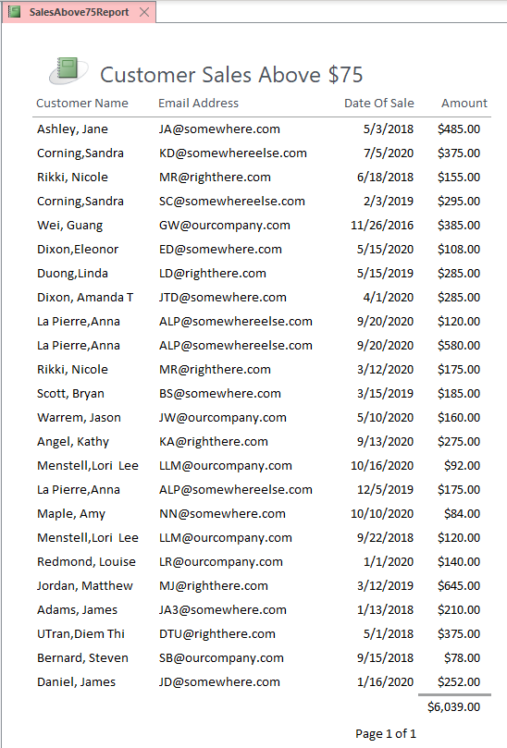

1. *Modify your report in part b to include subtotals for each customer.*

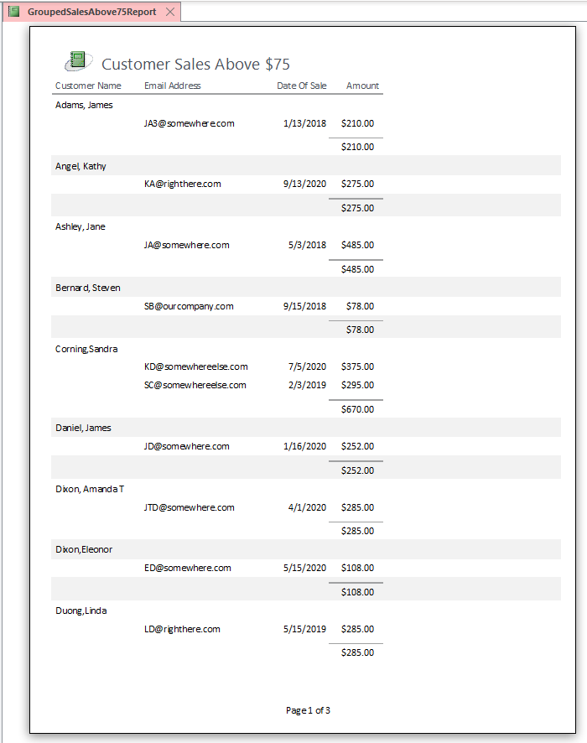

Report continues on next page…

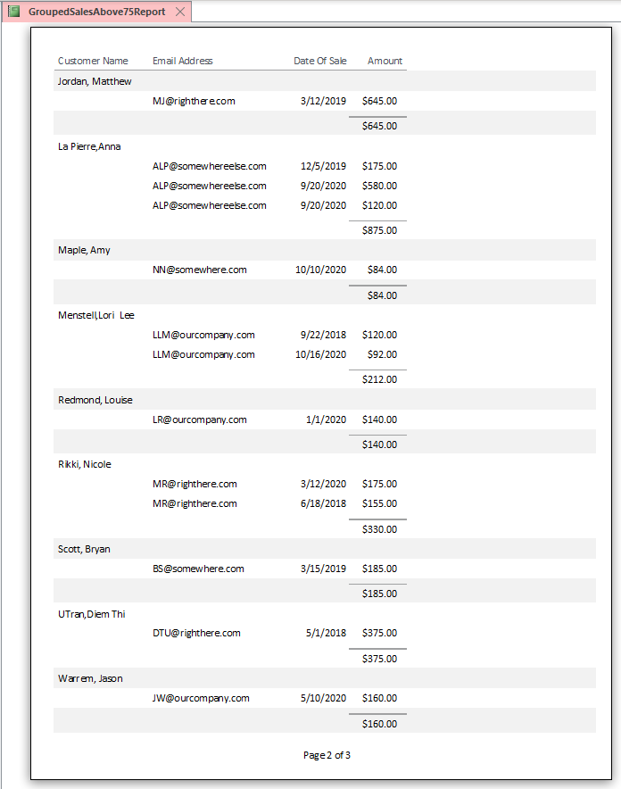

Report continues on next page…

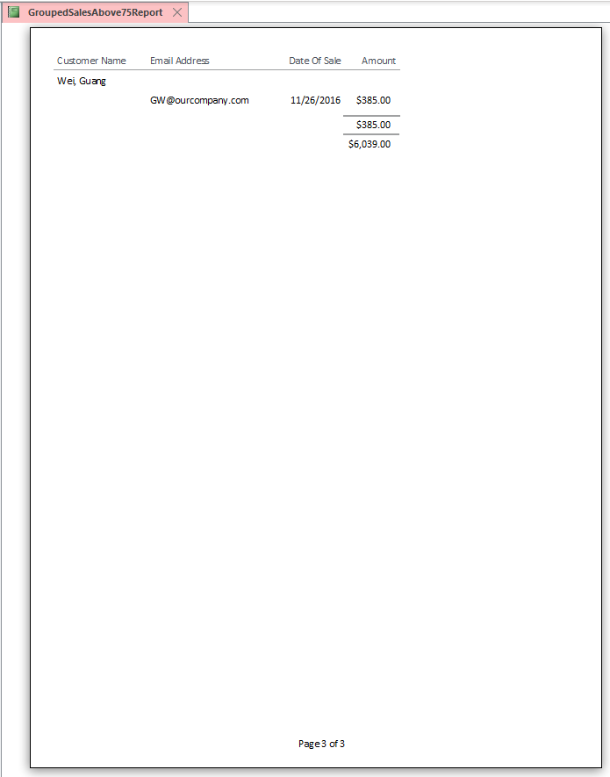

1. *Create a query to present the data as shown in Figure CE4-3. Produce a professionally formatted report of this data.*

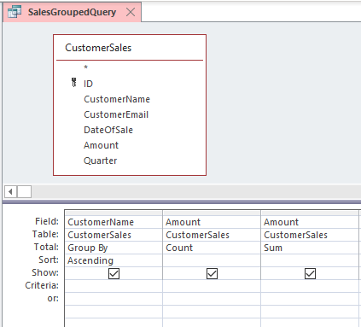

Report follows…

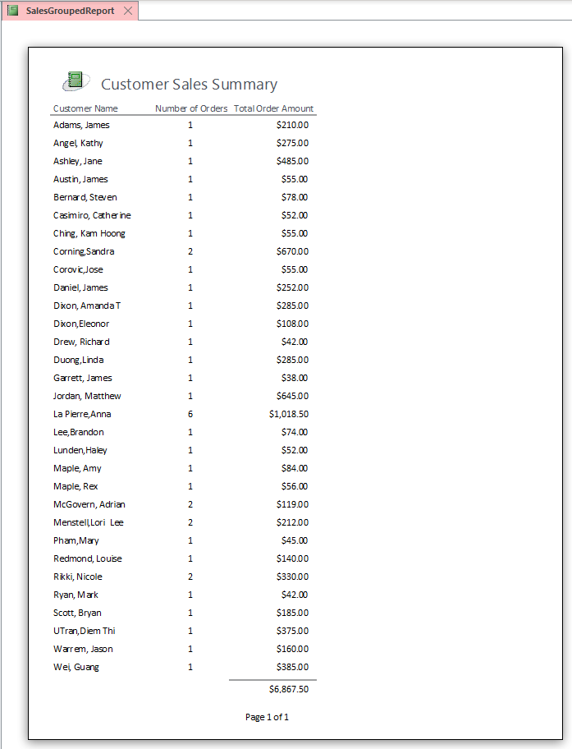

1. *Create a query to compute the average of Amount for each Quarter.*

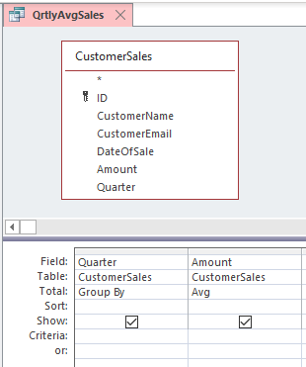

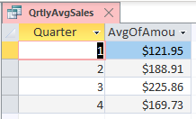

1. *Create a second table named QUARTER_DATA with fields* Quarter_Number *and* Average_Amount*. Place four rows in this table, one for each quarter and average amount.*

Make Table query:

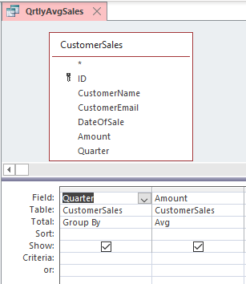

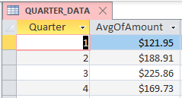

1. *Create a report that lists the sale data in ascending order of* CustomerName*. In your report, include the date and amount of each sale as well as the amount of the sale divided by the average amount of a sale for that quarter.*

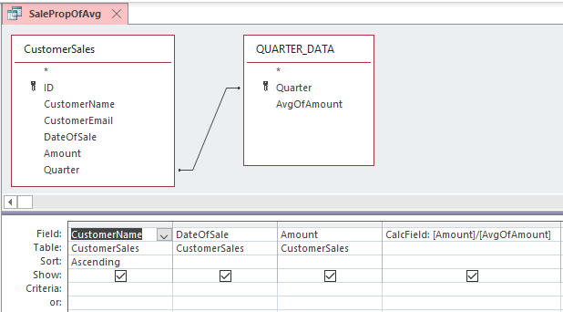

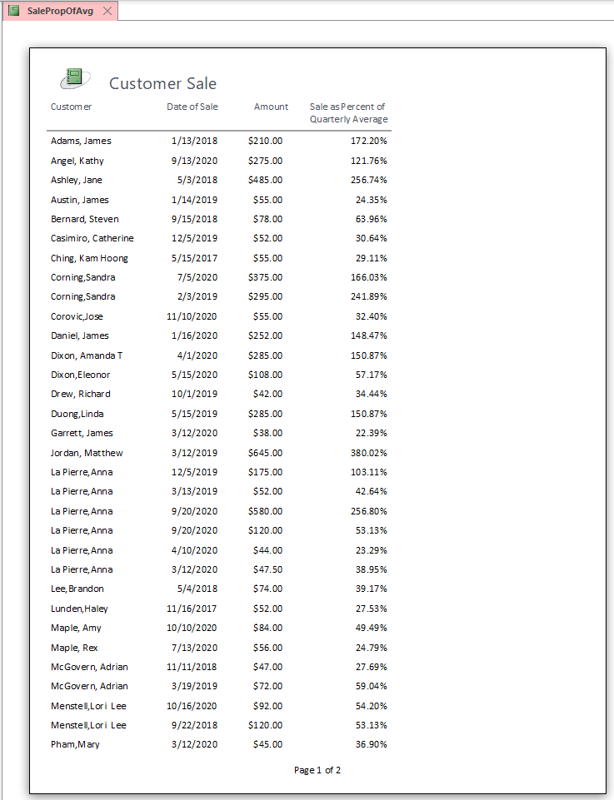

Report continues on next page…

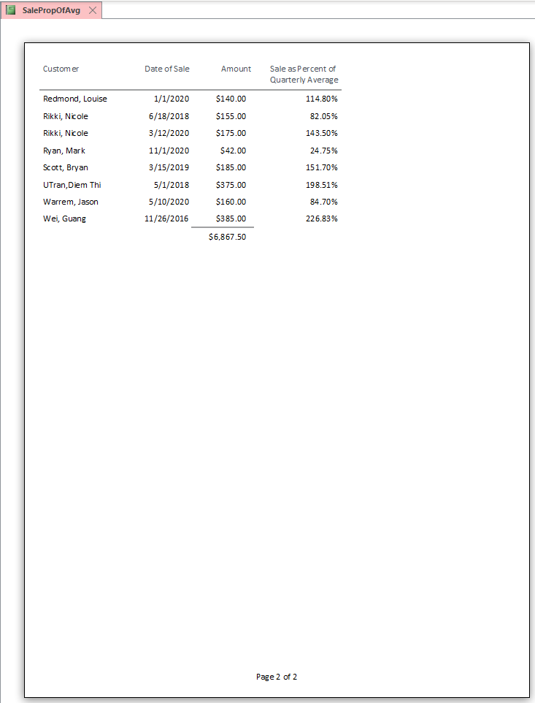

1. *Explain how all of the work you have done has been the result of the simple operations of filtering, sorting, grouping, and calculating.*

Part b involves selecting just the sales records with Amount >= $75 and sorting them. Part c involves adding a group to the report based on CustomerName and computing a group total. Part d involves a query to compute a count of each customer’s sales and a sum of each customer’s total purchases. Part e involves a query that computes an average for each quarter’s sales. Part f generates a new table from the part e query (using a Make Table query). Part g involves a query with a calculated field. (LO: 1, Learning Outcome: Compare and contrast different business intelligence systems, AACSB: Information Technology)

 Chapter Extension 4: OLAP and Pivot with Excel

1. *OLAP cubes are very similar to Microsoft Excel pivot tables. For this exercise, assume that in your organization’s purchasing agents rate vendors in the same way as the situation described in Application Exercise CE13-1.*

*a. Open the Excel file* ***CE4Ex02_E9e.xlsx****, which you can find on the text’s Web site. The spreadsheet has the following column headings:* VendorName, EmployeeName, Date, Year, *and* Rating*.*

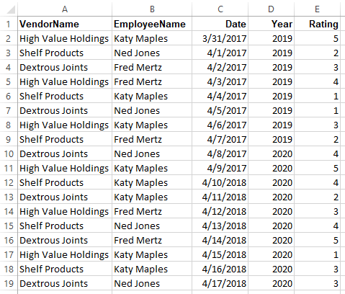

*b. Under the* Insert *ribbon in Excel, click* Pivot Table*.*

*c. When asked to provide a data range, drag your mouse over the column names and data values so as to select all of the data. Excel will fill in the range values in the open dialog box. Place your pivot table in a new worksheet. Click OK.*

*d. Excel will create a field list on the right-hand side of your spreadsheet. Underneath it, a grid labeled* Drag fields between areas below: *should appear. Drag and drop the field named* VendorName *into the area named ROWS. Observe what happens in the pivot table to the left (in column A). Now drag and drop* EmployeeName *onto COLUMNS and* Rating *onto VALUES. Again, observe the effect of these actions on the pivot table to the left. Voilà! You have a pivot table.*

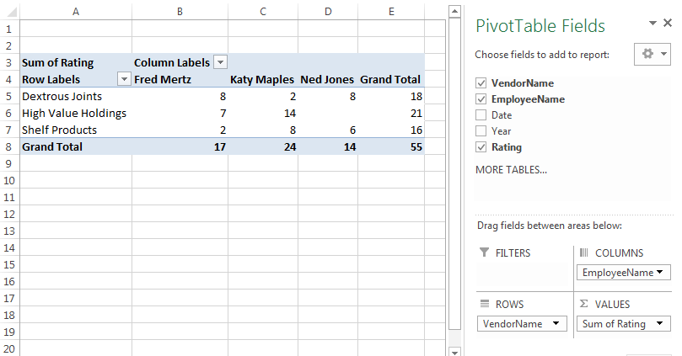

*e. To see how the pivot table works, drag and drop more fields onto the grid in the bottom right-hand side of your screen. For example, drop* Year *just underneath* Employee*. Then move* Year *above* Employee*. Now move* Year *below* Vendor*. All of this action is just like an OLAP cube, and in fact, OLAP cubes are readily displayed in Excel pivot tables. The major difference is that OLAP cubes are usually based on thousands or more rows of data.*

(Year below EmployeeName)

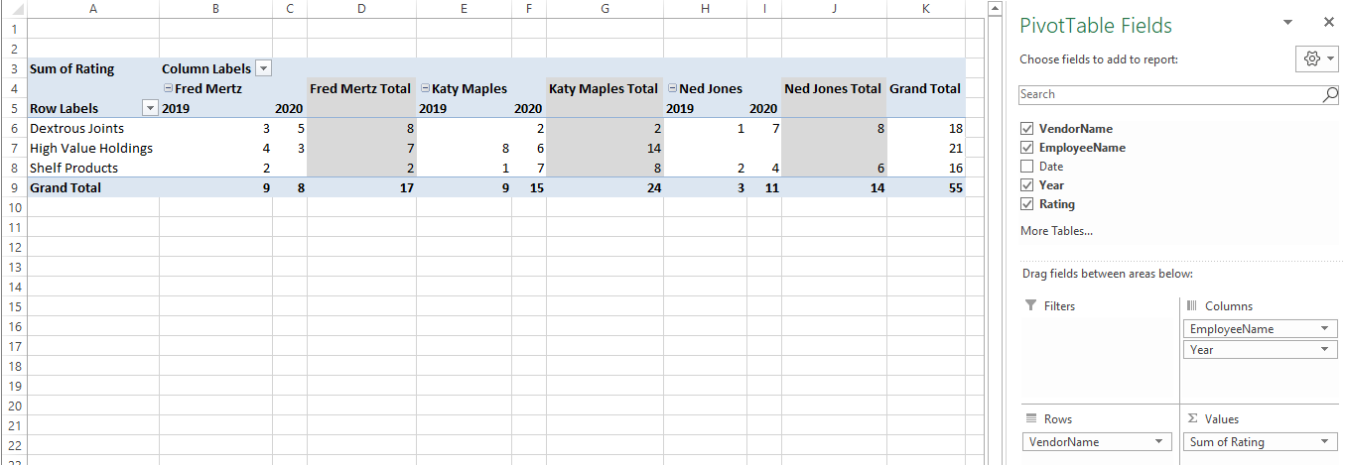

(Year above EmployeeName)

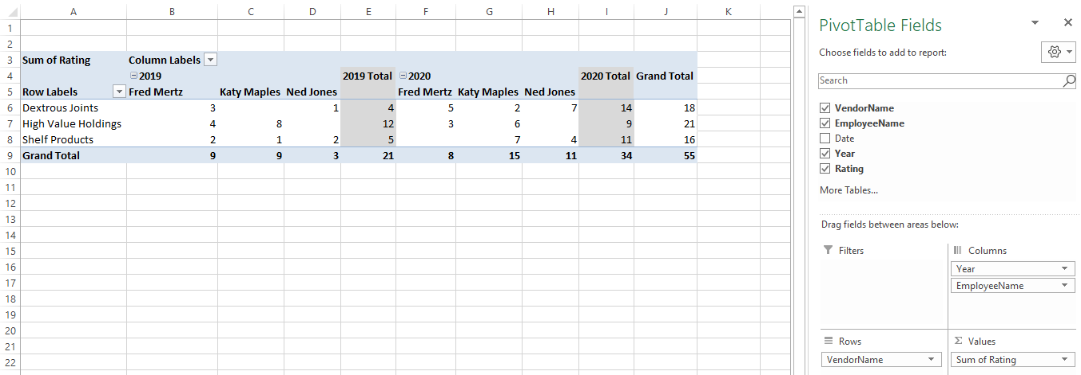

(Year below Vendor)

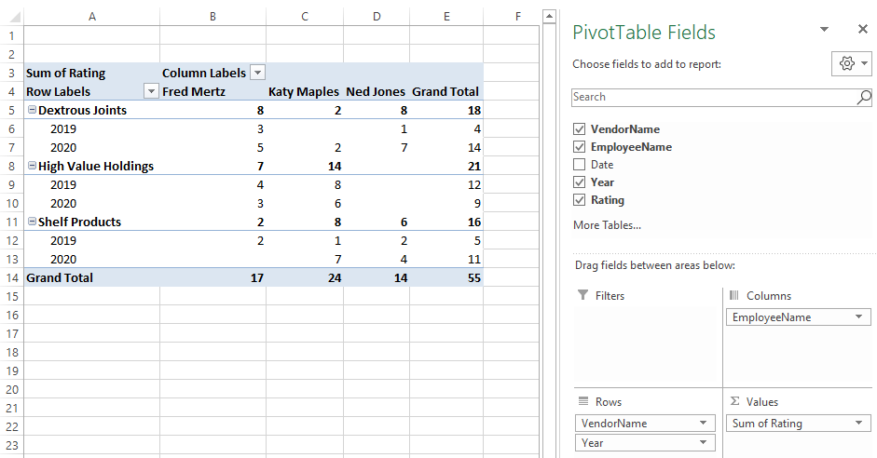

(LO: 4, Learning Outcome: Compare and contrast different business intelligence systems, AACSB: Information Technology)

PART 2

*Note: The exercises for the chapter extensions are basically tutorials. Therefore, they are presented first, followed by exercises for Chapters 4–6.*

Chapter Extension 6: Data Modeling with PowerPoint

1. *Complete Chapter Extension 6, CE6-2, page 432. Use PowerPoint to document your entity-relationship design.*

First, discuss with users the basic things to keep track of, the attributes of those things that are important, and how those things are related. With this information, we can propose a data model with entities, attributes, and relationships. In this example, an initial data model is shown.

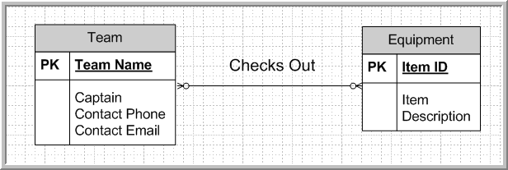

The many-to-many relationship can be resolved by adding a third entity to the data model in order to capture each occurrence of a team checking out a piece of equipment. An ID attribute has been created so that each equipment item is uniquely identified.

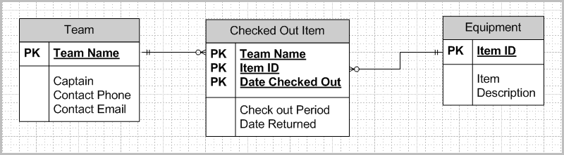

Once the users approve of the data model, we can create the database design and develop tables with foreign keys to represent the table relationships. As shown in the above data model, the Team Name, Item ID, and Date Checked Out serve as a concatenated primary key for the Checked Out Item entity. Team Name and Item ID are also foreign keys representing the relationships between Team and Checked Out Item, and Equipment and Checked Out Item. (LO: 3, Learning Outcome: Discuss best practices for using and managing databases, AACSB: Information Technology)

1. *Complete Chapter Extension 6, CE6-3, page 432. Use PowerPoint to document your entity-relationship design.*

First, discuss with users the basic things to keep track of, the attributes of those things that are important, and how those things are related. With this information, we can propose a data model with entities, attributes, and relationships. In this example, a data model is shown below.

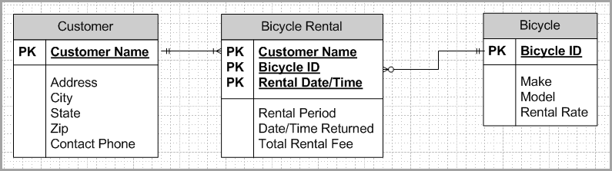

As shown in the data model above, the Customer Name, Bicycle ID, and Rental Date/Time serve as a concatenated primary key for the Bicycle Rental entity. Customer Name and Bicycle ID are also foreign keys representing the relationships between Customer and Bicycle Rental, and Bicycle and Bicycle Rental. (LO: 3, Learning Outcome: Discuss best practices for using and managing databases, AACSB: Information Technology)

Chapter Extension 7: Apply Access Skills

1. *Complete Chapter Extension 7, CE7-1, page 452. You are required to complete CE6-1 first.*

Note: Solutions created by students will vary. A sample solution is presented here.

Tables:

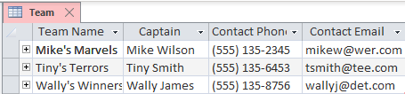

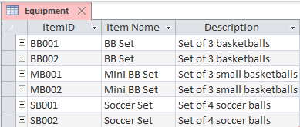

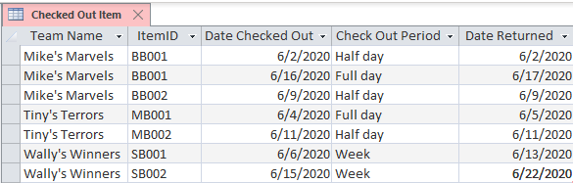

Data Entry Form:

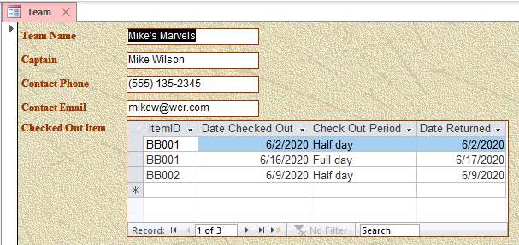

Report:

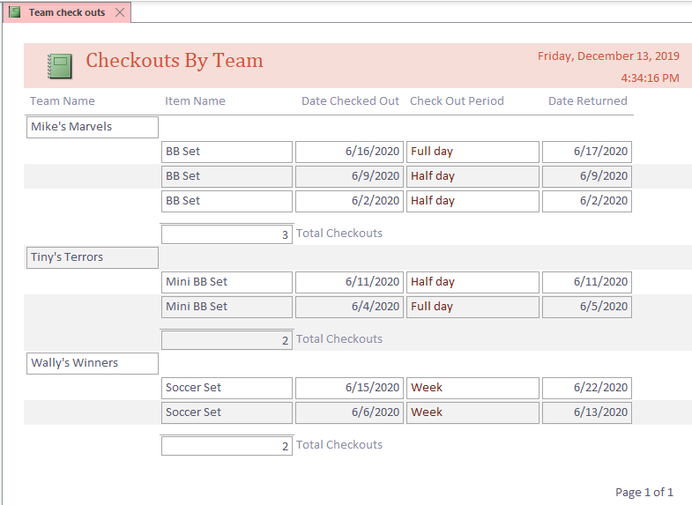

(LO: 1-5, Learning Outcome: Discuss best practices for using and managing databases, AACSB: Information Technology)

1. *Complete Chapter Extension 7, CE7-2, page 452. You are required to complete CE6-2 first.*

Note: Solutions created by students will vary. A sample solution is presented here.

Tables:

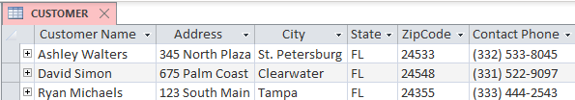

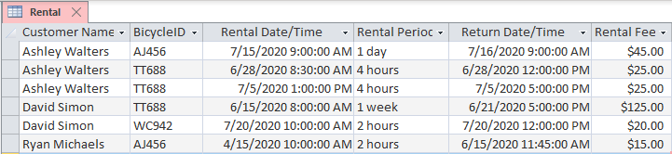

Data Entry Form:

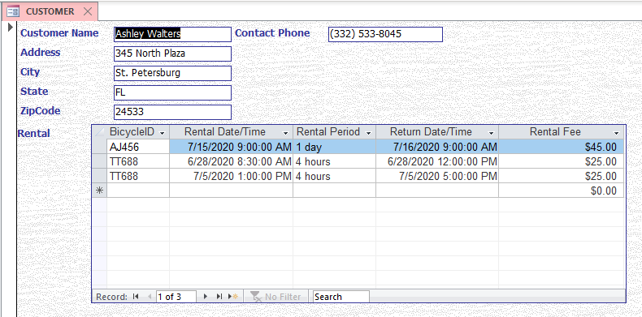

Report:

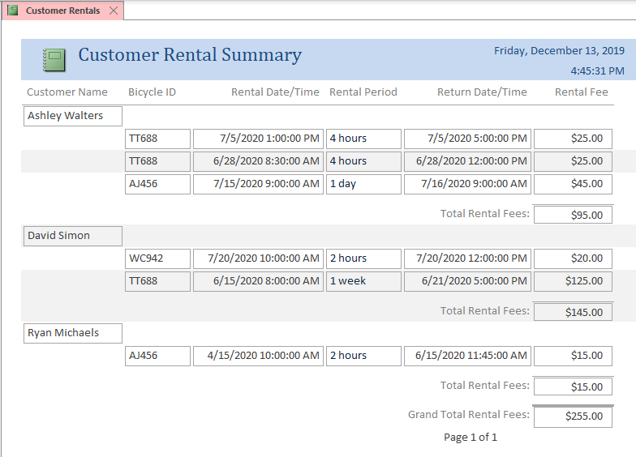

(LO: 1-5, Learning Outcome: Discuss best practices for using and managing databases, AACSB: Information Technology)

Chapter Extension 8: Getting the Best Features from Excel and Access

1. *Complete Chapter Extension 8, CE8-1, page 479.*

Note: Solutions created by students will vary. A sample solution is presented here.

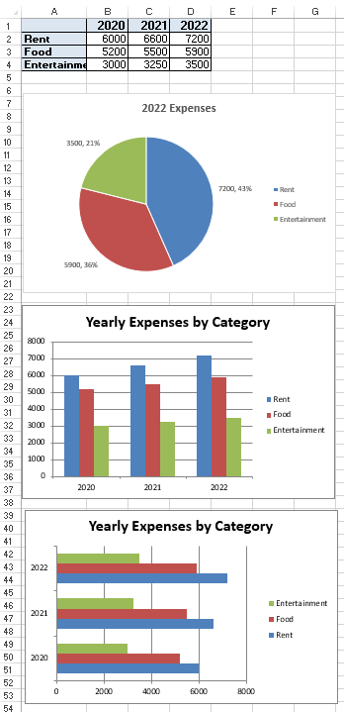

Most people prefer the column chart, but this is a matter of personal preference. Both chart types depict the same information. (LO: 3, Learning Outcome: Explain how information systems can be used to assist in decision making, AACSB: Information Technology)

1. *Complete Chapter Extension 8, CE8-2 and CE8-3, page 479.*

Note: Solutions created by students will vary. A sample solution is presented here.

Original My_Expenses table:

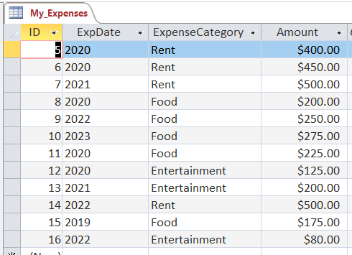

Query to sum by date:

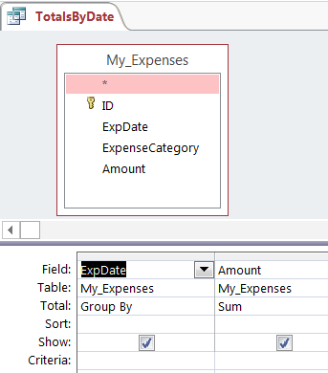

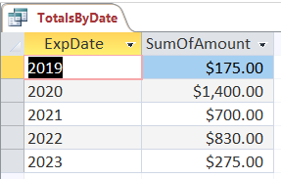

Query to compute sum and average by category

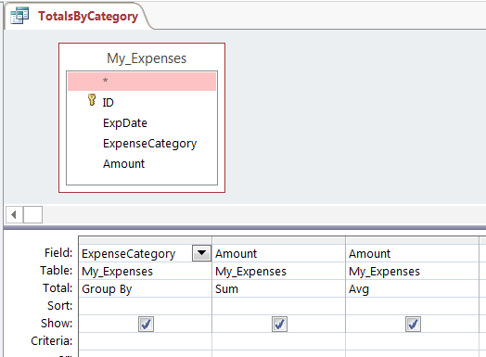

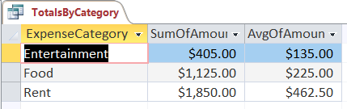

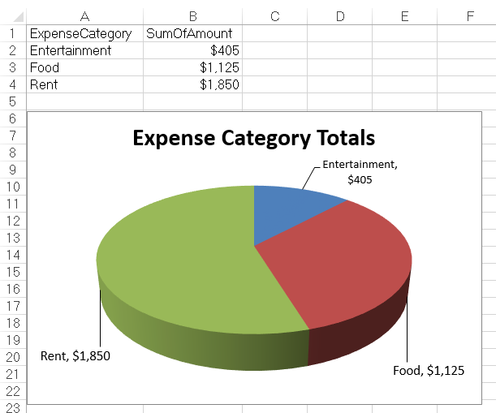

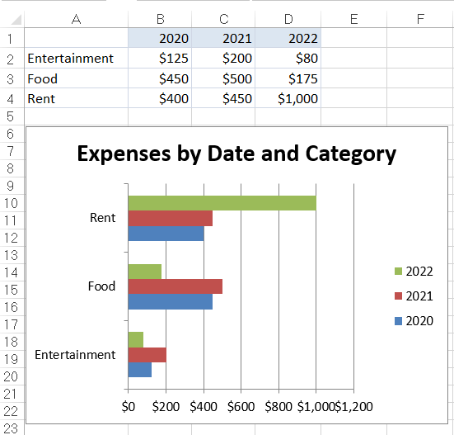

(LO: 4, Learning Outcome: Discuss best practices for using and managing databases, AACSB: Information Technology) and (LO: 5, Learning Outcome: Explain how information systems can be used to assist in decision making, AACSB: Information Technology)

AccessChapter 4: Using Parameterized Queries

1. *In this exercise, you will learn how to create a query based on data that a user enters and how to use that query to create a data entry form.*

## Download the Microsoft Access file Ch04Ex01_E9e.accdb. Open the file and familiarize yourself with the data in the Customer table.

## Click Create in the Access ribbon. Click the icon labeled Query Design. Select the Customer table as the basis for the query by clicking on Customer. Close the Show Table dialog. Drag CustomerName, CustomerEmail, DateOfLastRental, BikeLastRented, TotalNumberOfRentals, and TotalRentalRevenue into the columns of the query results pane (the table at the bottom of the query design window).

## In the CustomerName column, in the row labeled Criteria, place the following text:

## [Enter Name of Customer:]

*Type this entry exactly as shown, including the square brackets. This notation tells Access to ask you for a customer name to query.*

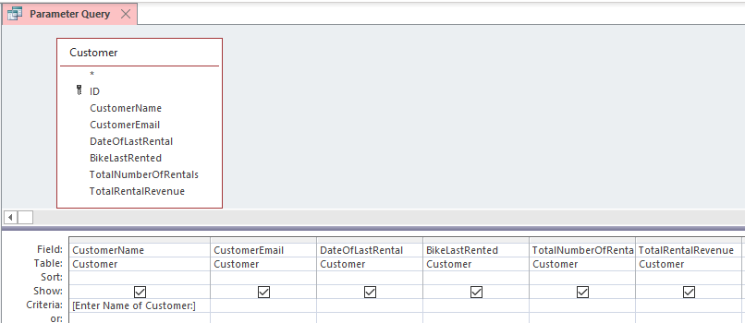

## In the ribbon, click the red exclamation mark labeled Run. Access will display a dialog box with the text “Enter Name of Customer:” (the text you entered in the query Criteria row). Enter the value Maple, Rex and click OK.

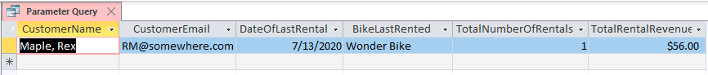

## Save your query with the name Parameter Query.

## Click the Home tab on the ribbon and click the Design View (upper left-hand button on the Home ribbon). Replace the text in the Criteria column of the CustomerName column with the following text. Type it exactly as shown:

**Like “*” & [Enter part of Customer Name to search by:] & “*”**

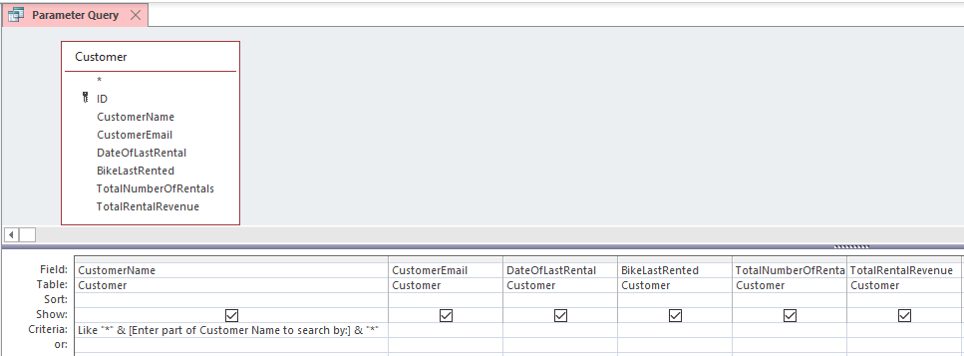

## Run the query by clicking Run in the ribbon. Enter Maple when prompted Enter part of Customer Name to search by. Notice that the two customers who have the name Maple are displayed. If you have any problems, ensure that you have typed the phrase previously shown exactly as shown into the Criteria row of the CustomerName column of your query.

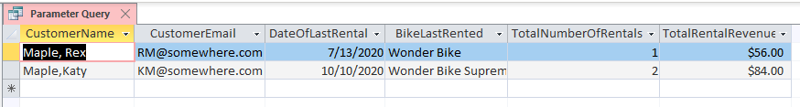

## Save your query again under the name Parameter Query. Close the query window.

## Click Create in the Access ribbon. Under the Forms group, choose Form Wizard. In the dialog that opens, in the Tables/Queries box, click the down arrow. Select Query: Parameter Query. Click the double chevron (>>) symbol, and all of the columns in the query will move to the Selected Fields area.

## Click Next two times. In the box under What title do you want for your form? enter Customer Query Form and click Finish.

1. *Enter* Maple *in the dialog box that appears. Access will open a form with the values for Maple, Rex. At the bottom of the form, click the right facing arrow and the data for the second customer named Maple will appear. What is that customer’s first name?*

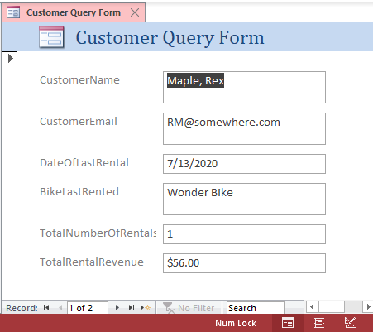

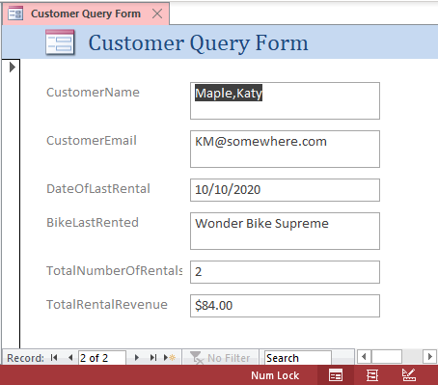

## Close the form. Select Object Type and Forms in the Access Navigation Pane. Double-click Customer Query Form, and enter the value Amanda. Access will display data for all three customers having the value Amanda in their name.

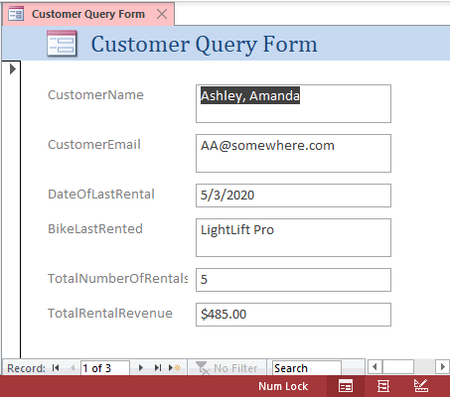

The user can scroll through the three records to view customers with Amanda in their names. (LO: 3, Learning Outcome: Discuss best practices for using and managing databases, AACSB: Information Technology)

Chapter 4: Using Excel and Access to Inform Computer Upgrade Decisions

1. *You have been asked to help your department decide how to upgrade computers. Let’s say, for example, that you want to upgrade all of the computers’ operating systems to Windows 10. Furthermore, you want to first upgrade the computers that most need upgrading, but suppose you have a limited budget. To address this situation, you would like to query the data in Figure AE-2, find all computers that do not have Windows 10, and then select those with slower CPUs or smaller memory as candidates for upgrading. To do this, you need to move the data from Excel and into Access.*

*Once you have analyzed the data and determined the computers to upgrade, you want to produce a report. In that case, you may want to move the data from Access and back to Excel or perhaps into Word. In this exercise, you will learn how to perform these tasks.*

1. *To begin, download the Excel file* ***Ch04Ex02_E9e.xlsx*** *from* www.pearsonhigher.com/kroenke *into one of your directories. We will import the data in this file into Access, but before we do so, familiarize yourself with the data by opening it in Excel. Notice that there are three worksheets in this workbook. Close the Excel file.*
2. *Create a blank Access database. Name the database* Ch04Ex02_Answer*. Place it in some directory; it may be the same directory into which you have placed the Excel file, but it need not be. Close the default table that Access creates and delete it.*
3. *Now, we will import the data from the three worksheets in the Excel file* ***Ch04Ex02_E9e*** *into a single table in your Access database. On the ribbon, select* External Data *and* Excel*. Start the import. For the first worksheet (Denver), you should select* Import the source data into a new table in the current database*. Ignore the warning about the first row by clicking OK. Be sure to click* First Row Contains Column Headings *when Access presents your data. You can use the default Field types and let Access add the primary key. Name your table* Employees *and click* Finish*. There is no need to save your import script.*

*For the second and third worksheets, again click* External Data/Excel*, but this time select* Append a copy of the records to the table Employees*. Select the Miami worksheet and click* Finish*. Repeat to import the Boston office employees.*

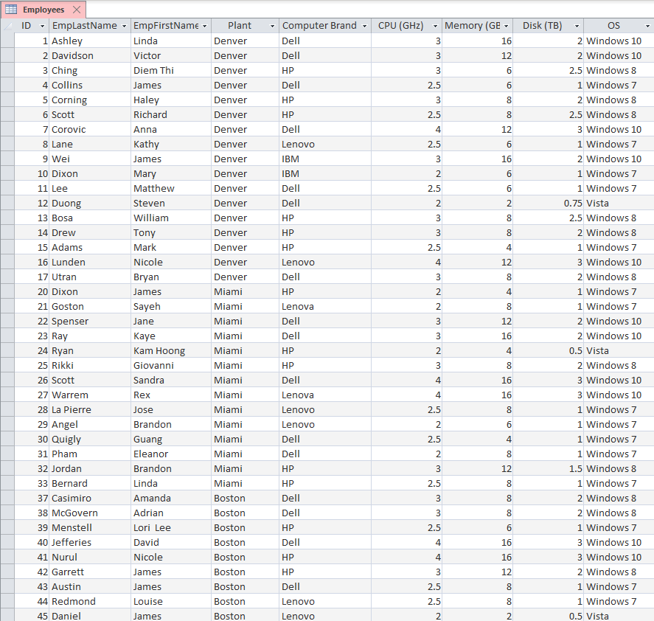

1. *Open the* Employee *table, and examine the data. Notice that Access has erroneously imported a blank line and the* Primary Contact *data into rows at the end of each data set. This data is not part of the employee records, and you should delete it (in three places—once for each worksheet). The* Employee *table should have a total of 40 records.*
2. *Create a parameterized query on this data. Place all of the columns except* ID *into the query. In the* OS *column, set the criteria to select rows for which the value is not* Windows 10*. In the* CPU *(GHz) column, enter the criterion:* <=[Enter cutoff value for CPU] *and in the* Memory *(GB) column, enter the criterion:* <=[Enter cutoff value for Memory]*. Test your query. For example, run your query and enter a value of 4 for CPU and 10 for memory. Verify that the correct rows are produced.*

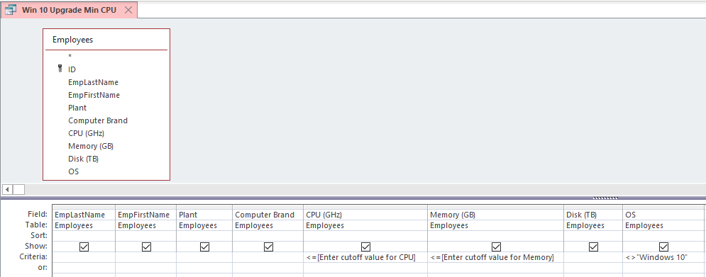

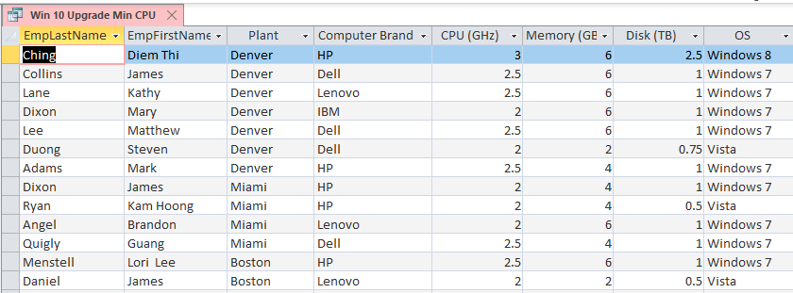

1. *Use your query to find values of CPU and memory that give you as close to a maximum of 10 computers to upgrade as possible.*

By experimenting with different values for CPU and memory, students will discover that a CPU value of 2 and memory value of 6 produces a result of 6 computers. The next increment of CPU value = 2.5 and memory value = 6 produces a list of 12 computers. Trying CPU value = 3 and memory value = 6 lists 13 computers (shown above). This combination is as close to 15 as we can get, because the next increment of CPU value = 3 and memory value = 8 lists 27 computers, which is over the prescribed limit of 15 computers.

1. *When you have found values of CPU and memory that give you 10, or nearly 10, computers to upgrade, leave your query open. Now, click* External data*,* Word*, and create a Word document that contains the results of your query. Adjust the column widths of the created table so that it fits on the page. Write a memo around this table explaining that these are the computers that you believe should be upgraded.*

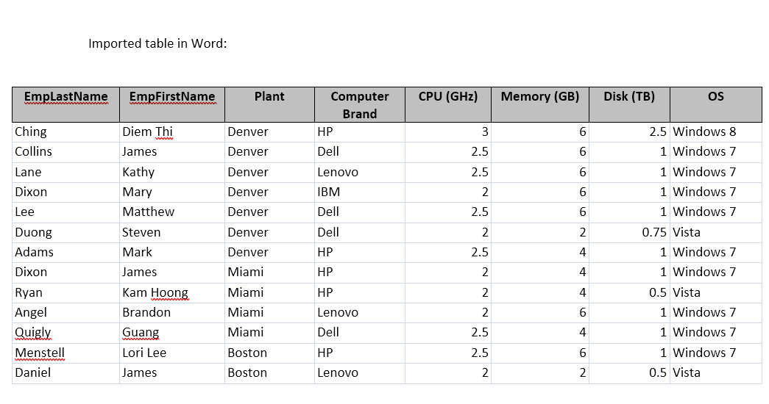

(LO: 2, Learning Outcome: Describe the major types of computer hardware and software used by companies, AACSB: Information Technology)

Chapter 4: Using Open Source Software

1. *As you read in Chapter 4, open source software is popular because it’s stable, customizable, and free. But you may not have used open source software before. In this project, you will download an alternate to the Microsoft Office suite called LibreOffice. It has applications for making documents (Writer), spreadsheets (Calc), presentations (Impress), databases (Base), and graphics (Draw) similar to those in Microsoft Office.*

*If you’re used to Microsoft Office, it will take some time to become familiar with the LibreOffice interface. LibreOffice can do just about everything Microsoft Office can do, but it does it in a slightly different way. The main benefit of using LibreOffice is that it’s totally free. You can install it as many times as you’d like on as many computers as you’d like.*

1. *Browse to* [www.libreoffice.org](http://www.libreoffice.org)*.*

No specific answer; a task to be performed by the student

1. *Click on the Download menu and select LibreOffice Fresh.*

No specific answer; a task to be performed by the student

1. *Download and install the latest version of LibreOffice. (There are LibreOffice versions for Windows, macOS, and Linux.)*

No specific answer; a task to be performed by the student

1. *Open LibreOffice Calc. (There will be a shortcut on your desktop.)*

No specific answer; a task to be performed by the student

1. *Enter your name, date, and time into the new spreadsheet in cells A1, A2, and A3, respectively.*

No specific answer; a task to be performed by the student

1. *Click Tools and Options.*

No specific answer; a task to be performed by the student

1. *Expand the Load/Save menu and click on General.*

No specific answer; a task to be performed by the student

1. *Change the “Always save as” dropdown from ODF Spreadsheet to Microsoft Excel 2007-2013 XML and click OK. (You can do the same thing for documents and presentations.)*

No specific answer; a task to be performed by the student

1. *Click File, Save, and Save.*

No specific answer; a task to be performed by the student

1. *Take a screenshot with your name showing and paste it into your document. (You can take a screenshot by pressing Alt+Print Screen.)*

No specific answer; a task to be performed by the student

1. *Explain why more people don’t use LibreOffice if it’s free.*

The pervasiveness of Office may make people reluctant to change, especially if there is any concern about file compatibility between the two products.

1. *Explain why a systems administrator, who manages hundreds of servers (with Linux and Windows operating systems), might like using LibreOffice.*

The open-source form of LibreOffice means that the systems administrator does not have to be worried about the number of user licenses for the product.

1. *Explain why LibreOffice might be an important application for users or organizations in developing countries.*

In developing countries with scarce resources, this application is freely available and can enable users to become proficient with these personal productivity tools without any application software expenditures.

(LO: 1, Learning Outcome: Explain how information systems can be used to assist in decision making, AACSB: Information Technology)

**Chapter 5: Graphing with Excel

1. *In some cases, users want to use Microsoft Access with Excel together. They process relational data with Access, import some of the data into Excel, and use Excel’s tools for creating professional-looking charts and graphs. You will do exactly that in this exercise.*

*Download the Access File* ***Ch05Ex01_E9e.accdb*** *from* [www.pearsonhighered.com/kroenke](http://www.pearsonhighered.com/kroenke)*. Open the database; select* DATABASE TOOLS/Relationships*. As you can see, there are three tables,* Product*,* VendorProductInventory*, and* Vendor*. Open each table individually to familiarize yourself with the data.*

*For this problem, we will define* InventoryCost *as the product of* IndustryStandardCost *and* QuantityOnHand*. The query* InventoryCost *computes these values for every item in inventory for every vendor. Open that query and view the data to be certain you understand this computation. Open the other queries as well so that you understand the data they produce.*

1. *Sum this data by vendor and display it in a pie chart. Proceed as follows:*
2. *Open Excel and create a new spreadsheet.*
3. *Click* DATA *on the ribbon, and select* FromAccess *in the* Get External Data *ribbon category.*
4. *Navigate to the location in which you have stored the Access File* ***Ch05Ex01_E9e.accdb.***
5. *Select the query that contains the data you need for this pie chart.*
6. *Import the data into a worksheet.*
7. *Format the appropriate data as currency.*
8. *Select the range that contains the data, press the function key and proceed from there to create the pie chart. Name the data and pie chart worksheets appropriately.*

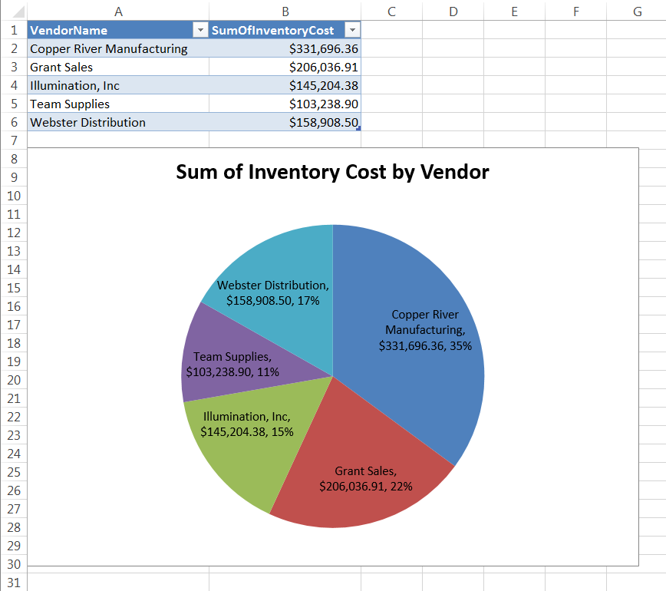

1. *Follow a similar procedure to create a bar chart. Place the data and chart in separate worksheets, and name them appropriately.*

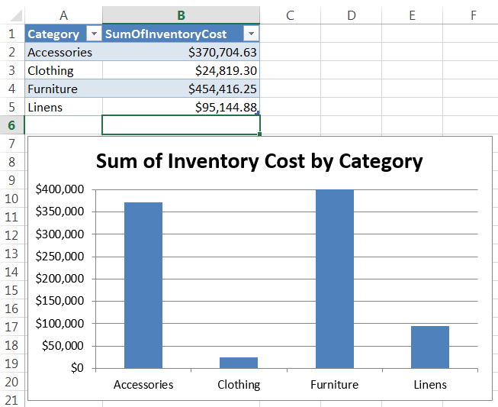

(LO: 1, Learning Outcome: Explain how information systems can be used to assist in decision making, AACSB: Information Technology)

**Chapter 5: Find the Pianos!

1. *Read Case Study 5 on pages 140–142. A copy of Dean’s database is stored in the Access file* ***Ch05Ex02_E9e.accdb****. Download a copy of this file and create queries to provide the following data:*

*a. Sort the pianos from high quality to low.*

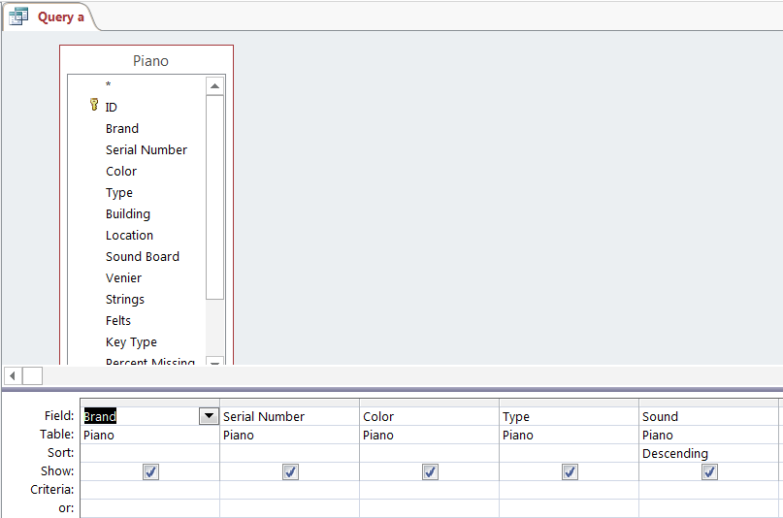

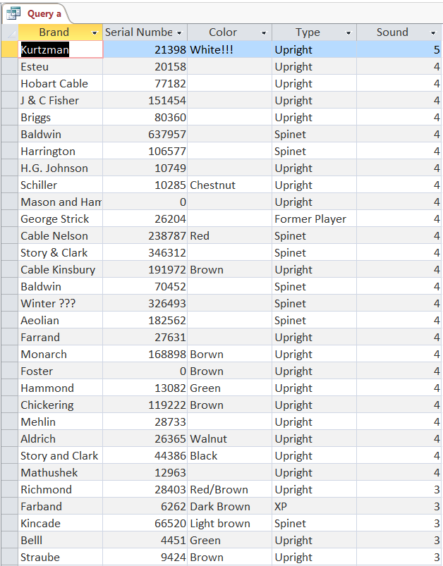

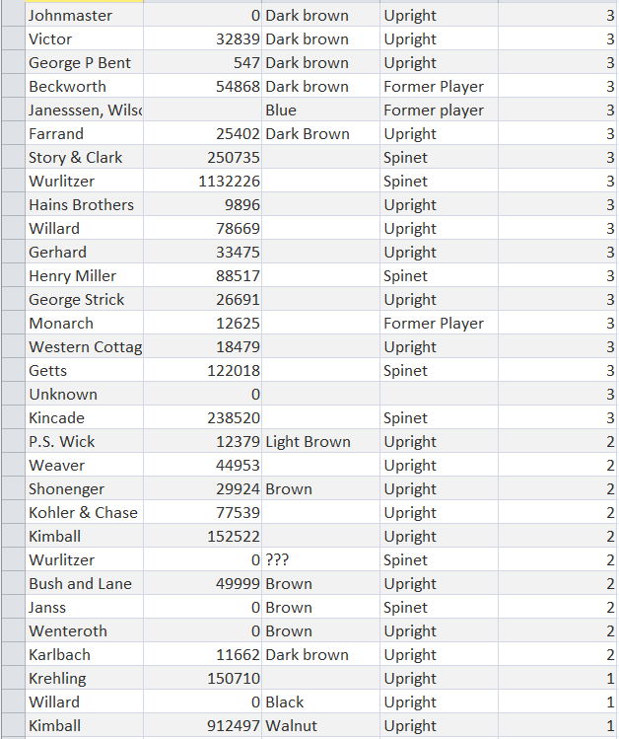

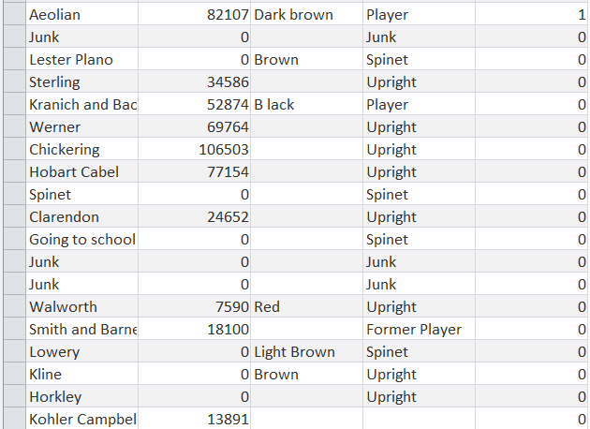

*b. Sort the pianos from high quality to low, and, within each quality, sort by Building and then by Location within that building.*

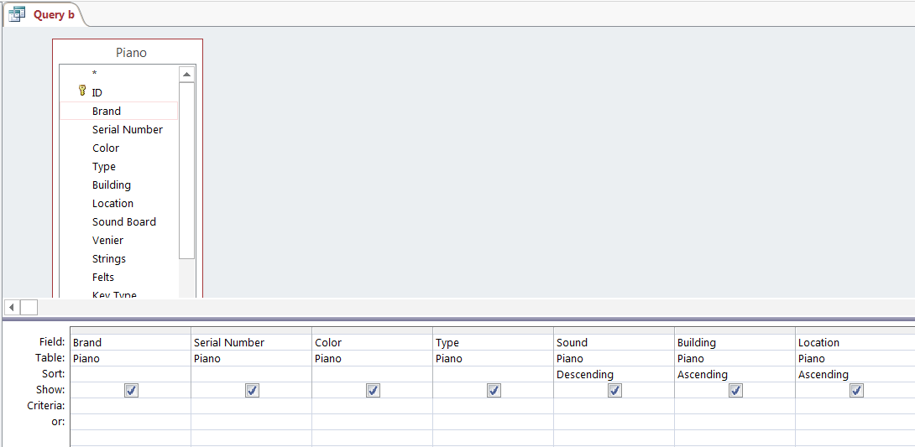

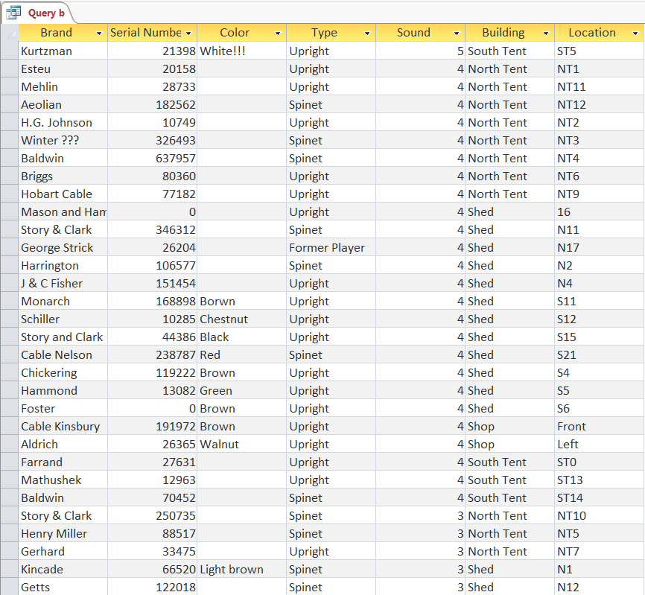

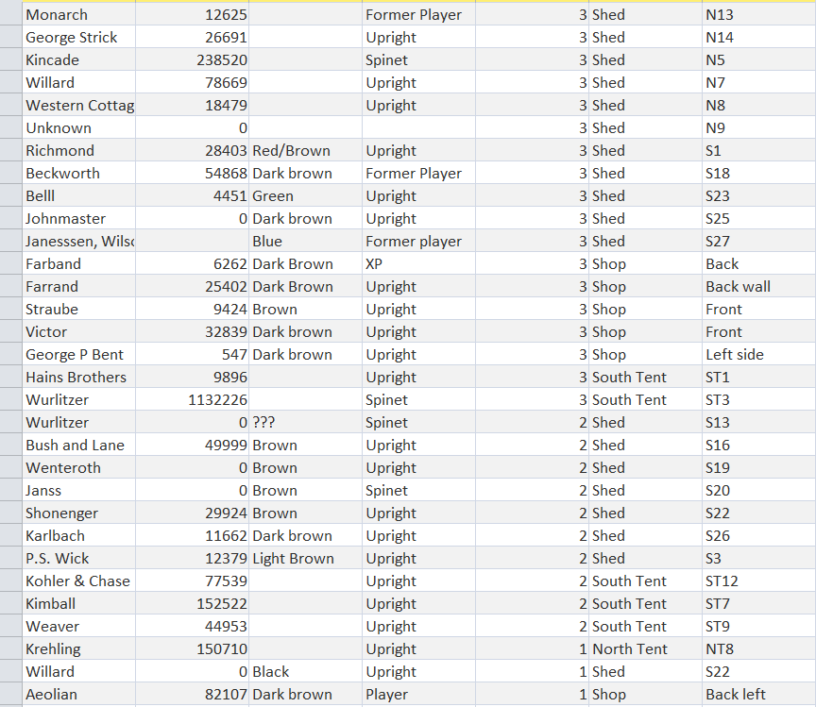

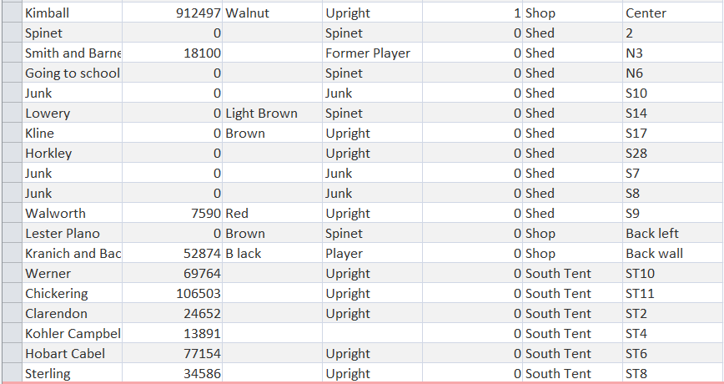

*c. List the pianos in the shed and sort the results by manufacturer.*

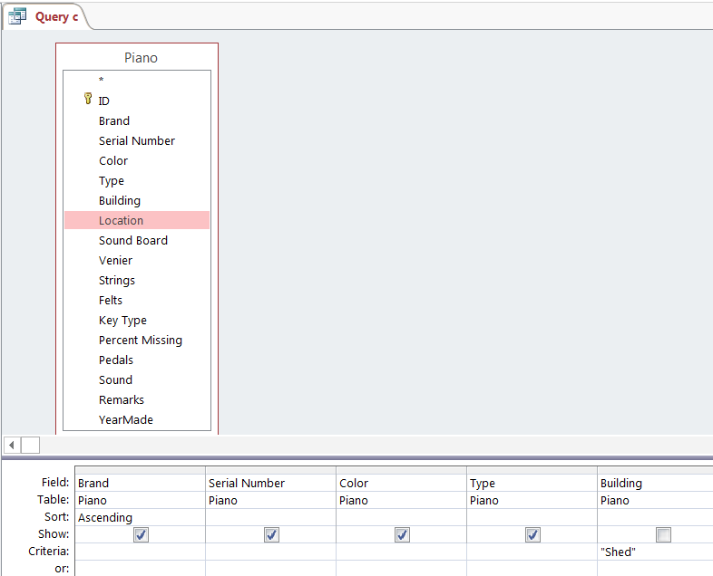

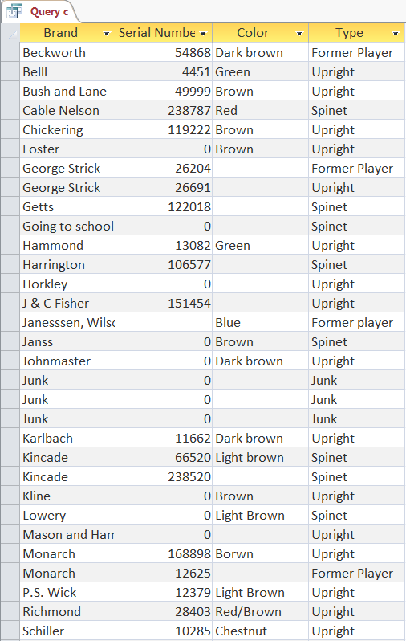

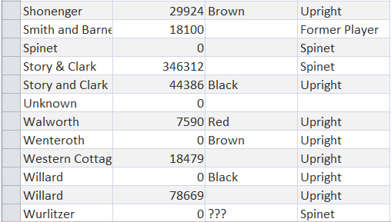

*d. List all of the pianos with a Type of ‘Spinet.’*

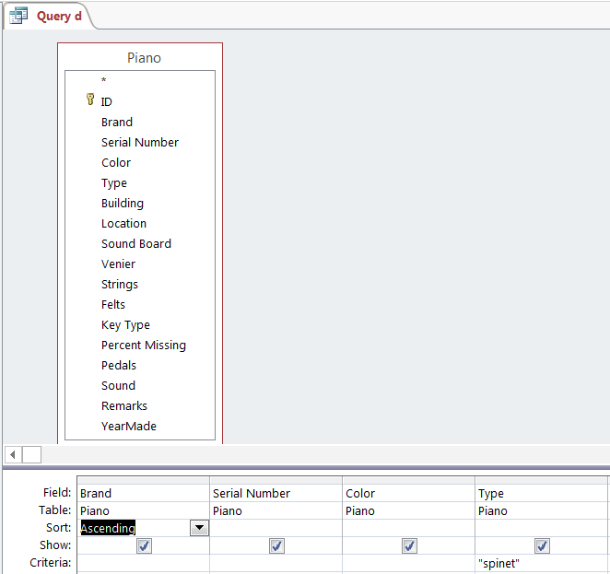

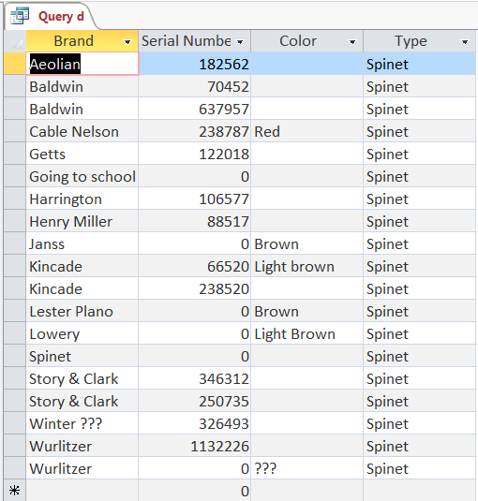

*e. Count the pianos for each value of quality (ranging from 1 to 5).*

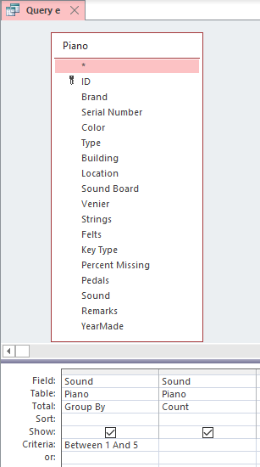

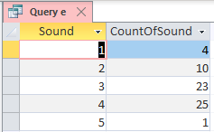

*f. Write a query to produce the report in Figure 5-23 on page 144.*

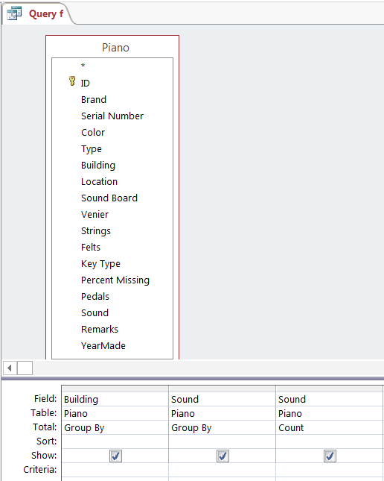

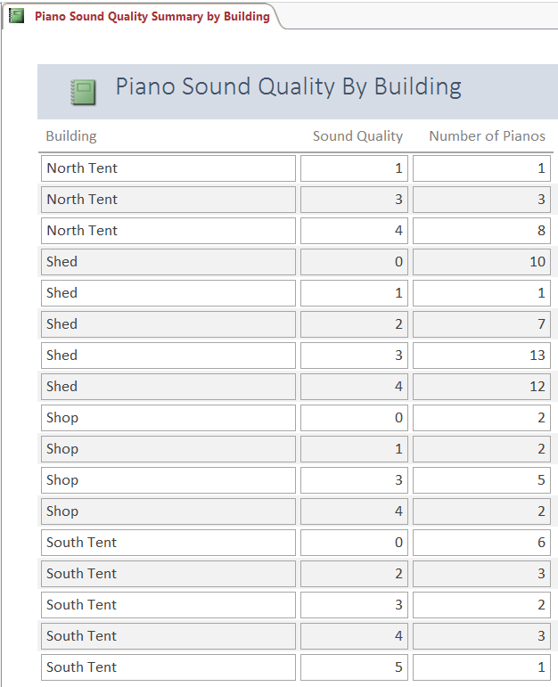

(LO: 1, Learning Outcome: Explain how information systems can be used to assist in decision making, AACSB: Information Technology)

**Chapter 5: Use Access to Allocate Computers to Employees

1. *In this exercise, you will create a two-table database, define relationships, create a form and a report, and use them to enter data and view results.*

*a. Download the Excel file named* ***Ch05Ex03_E9e.xlsx*** *from* [www.pearsonhighered.com/kroenke](http://www.pearsonhighered.com/kroenke). *Open the spreadsheet and review the data in the* Employee *and* Computer *worksheets.*

*b. Create a new Access database with the name* Ch05Ex5-3_Solution*. Close the table that Access automatically creates and Access will delete it.*

*c. Import the data from the Excel spreadsheet into your database. Import the* Employee *worksheet into a table name* Employee*. Be sure to check* First Row Contains Column Headings*. Select* Choose my own primary key *and use the ID field as that key.*

1. *Import the* Computer *worksheet into a table named* Computer*. Check* First Row Contains Column Headings, *but let Access create the primary key.*
2. *Open the relationships window and add both* Employee *and* Computer *to the design space. Drag* ID *from* Employee *and drop it on* EmployeeID *in* Computer*. Check* Enforce Referential Integrity *and the two checkmarks below. Be sure you know what these actions mean.*
3. *Open the Form Wizard dialog box (under* Create*,* Form Wizard*) and add all of the columns for each of your tables to your form. Select* View your data by Employee*. Title your form* Employee *and your subform* Computer*.*
4. *Open the* Computer *subform in design mode and delete* EmployeeID *and* ComputerID*. These values are maintained by Access, and it is just a distraction to keep them. Save your changes and open the Employee form in layout mode. Adjust the size of the subform until your form looks like that in Figure AE-3.*
5. *Use your form to add two new computers to* Michael Murphy. *Both computers are Dells, and both use Windows 10; one costs $1,750, and the other costs $1,400.*

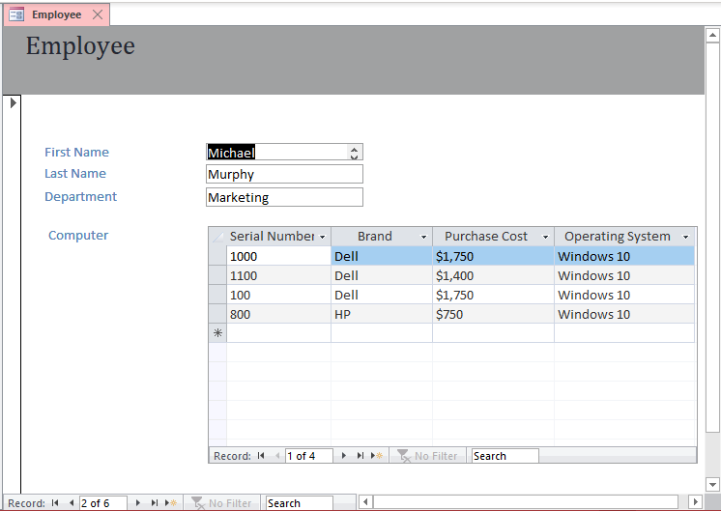

1. *Delete the Lenovo computer for Hal Larsen.*
2. *Use the Report Wizard (under* Create*) to create a report having all data from both the* Employee *and* Computer *tables. Adjust the report design until you find a design you like. Correct the label alignment if you need to.*

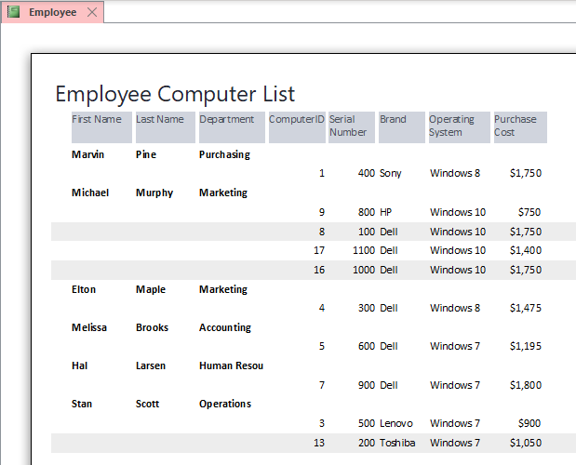

(LO: 3, Learning Outcome: Discuss best practices for using and managing databases, AACSB: Information Technology)

Chapter 6: Internet Speed: Getting What You Pay For?

1. *Numerous Web sites are available that will test your Internet data communications speed. You can find a good example at* www.measurementlab.net/tests/ndt/. *(If that site is no longer active, Google or Bing “What is my Internet speed?” to find another speed-testing site.)*
2. *While connected to your university’s network, go to* [www.measurementlab.net/tests/ndt/](http://www.measurementlab.net/tests/ndt/) *and click* Start Test*. Record your average upload and download speeds.*

Student answers will vary, depending on the specific data communication configuration in use. (LO: 3, Learning Outcome: Compare and contrast different ways of connecting to the Internet, AACSB: Information Technology)

1. *Go home, or to a public wireless site, and run the* [www.measurementlab.net/tests/ndt/](http://www.measurementlab.net/tests/ndt/) *test again. Compute your average upload and download speeds. If you are performing this test at home, are you getting the performance you are paying for?*

Student answers will vary, depending on the specific data communication configuration in use. (LO: 3, Learning Outcome: Compare and contrast different ways of connecting to the Internet, AACSB: Information Technology)

1. *Contact a friend or relative in another state. Ask him or her to run the* [www.measurementlab.net/tests/ndt/](http://www.measurementlab.net/tests/ndt/) *test. Report the upload and download speeds.*

Student answers will vary, depending on the specific data communication configuration in use. (LO: 3, Learning Outcome: Compare and contrast different ways of connecting to the Internet, AACSB: Information Technology)

1. *Compare the results in parts a-c. What conclusion, if any, can you make from these tests?*

Student answers will vary, depending on the specific data communication configuration in use. (LO: 3, Learning Outcome: Compare and contrast different ways of connecting to the Internet, AACSB: Information Technology)

**Chapter 6: Estimating Cloud Costs with Excel

1. *Assume you have been asked to create an Office application to estimate cloud computing costs. You decide to create a spreadsheet into which your customers can provide their cloud computing needs and which you can then import into an Access database, using queries to compute cloud computing costs.*

*Figure AE-4 shows the structure of the spreadsheet into which your customers will input their requirements. You can download this spreadsheet in the Excel file* ***Ch06Ex02_E9e.xlsx****. Figure AE-5 shows an Access table that has costs corresponding to the requirements in Figure AE-4. You can download this database in the Access file* ***Ch06Ex02_E9e.accdb****.*

1. *Import the spreadsheet data into the Access database.*

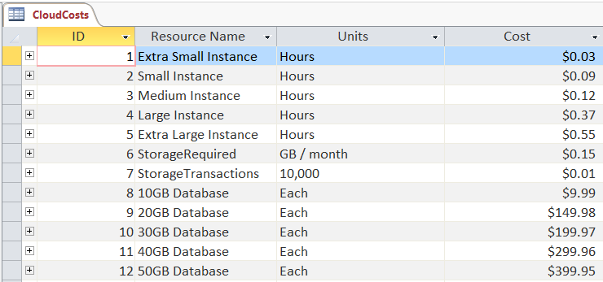

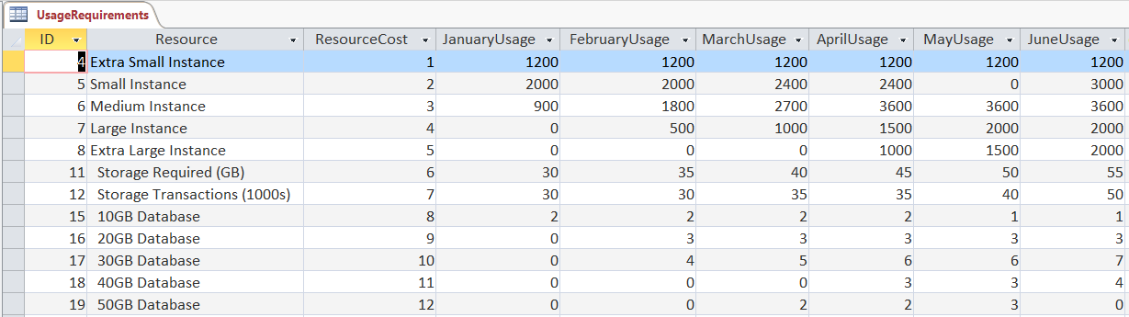

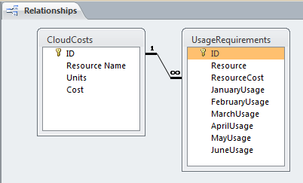

*b. Write queries to compute the cost of each resource.*

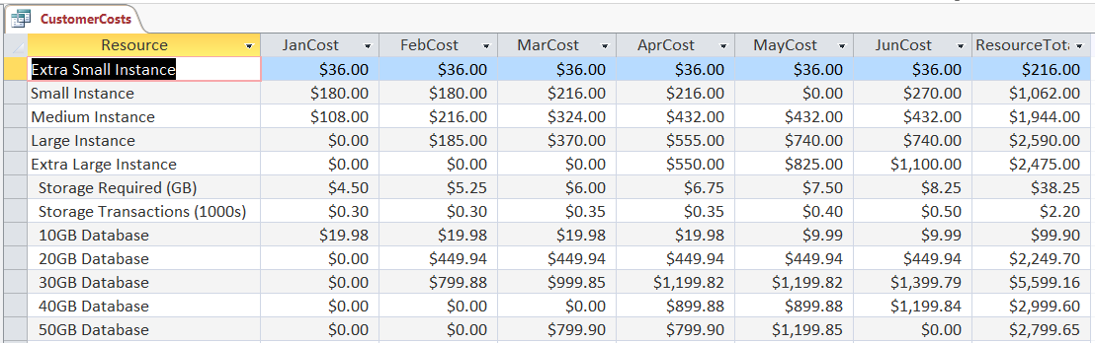

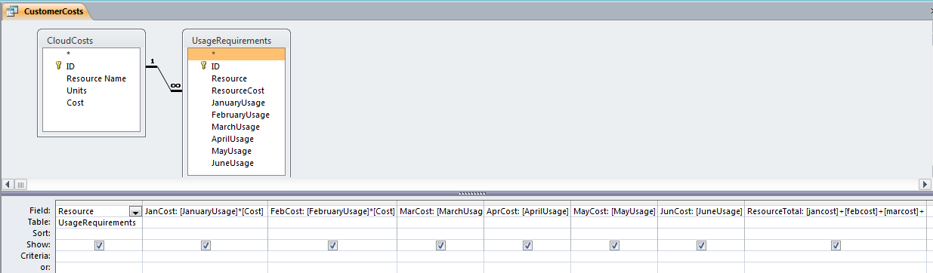

(LO: 5, Learning Outcome: Compare and contrast different ways of connecting to the Internet, AACSB: Information Technology)

*c. Create a report that shows the cost for each type of resource for each month. Show the total costs for the 6-month period for each resource as well. Include a grand total of all the costs.*

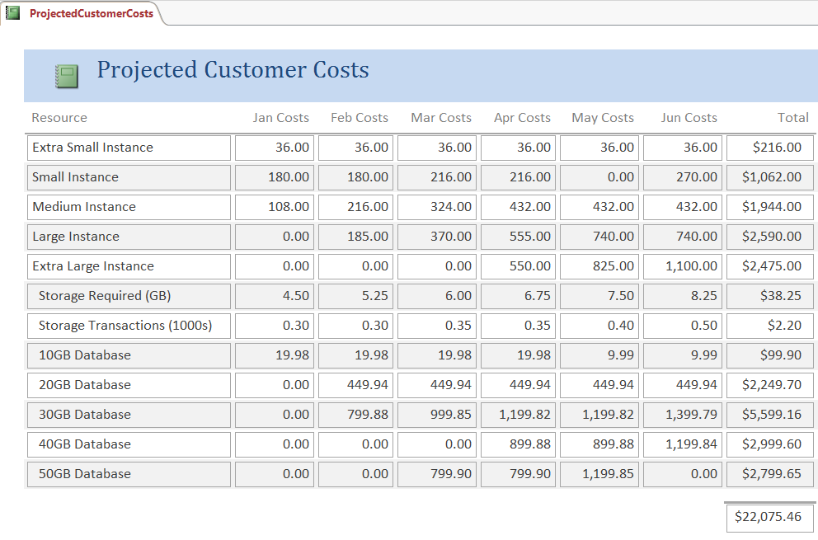

(LO: 5, Learning Outcome: Compare and contrast different ways of connecting to the Internet, AACSB: Information Technology)

1. *Create a pie chart that breaks out the total costs by resource.* Hint*: You have to import the query data back into Excel.*

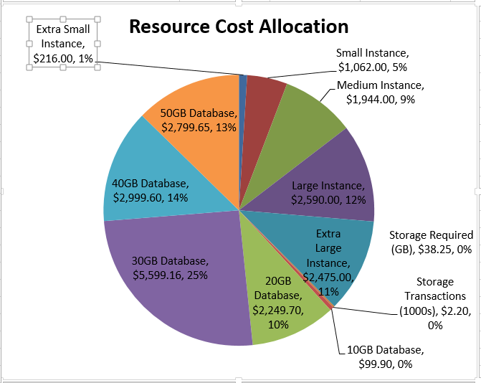

(LO: 5, Learning Outcome: Compare and contrast different ways of connecting to the Internet, AACSB: Information Technology)

*e. Create a pie chart that breaks out the total costs by month.* Hint*: You have to import the query data back into Excel.*

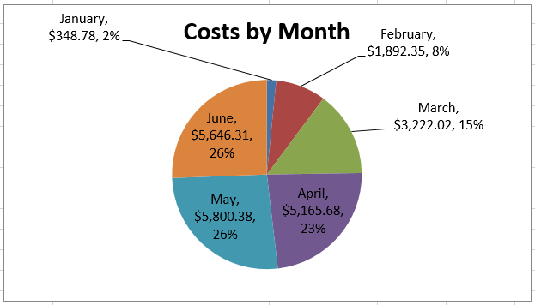

(LO: 5, Learning Outcome: Compare and contrast different ways of connecting to the Internet, AACSB: Information Technology)

*f. Assume that processing costs increase by 10 percent across the board. Repeat parts c, d, and e for the changed costs.*

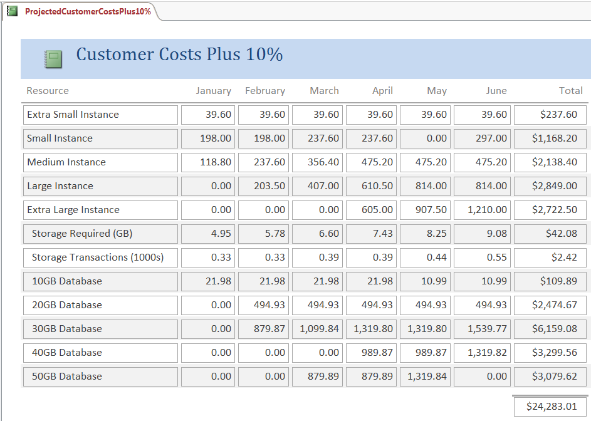

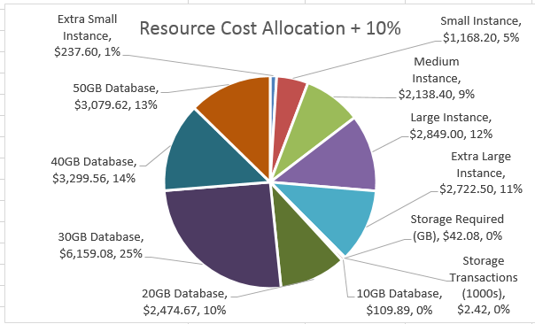

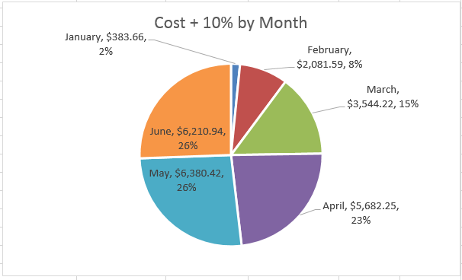

(LO: 5, Learning Outcome: Compare and contrast different ways of connecting to the Internet, AACSB: Information Technology)

Chapter 6: File Compression and Encryption

1. *There are a few problems with cloud-based storage. First, it seems like there’s never enough of it. This is especially true if it’s free. Second, you always wonder if it’s really secure. Yes, your storage provider says your data is secure. But is it really? Is there some way to be sure?*

*In this project, you will learn how to use 7-Zip to solve both of these problems. You’ll learn how to compress and encrypt important files and directories. If you are storing confidential data in the cloud, it’s important to make sure it’s encrypted—by you. Using a third-party encryption tool like 7-Zip means only* you *can access your data. Trusting your cloud providers isn’t necessary. 7-Zip is also a very efficient file archiver that will save you a lot of space.*

1. *Browse to* [www.7-zip.org](http://www.7-zip.org)*.*

No specific answer; a task to be performed

1. *Click on Download and install the latest version of 7-Zip for your operating system. (There are 7-Zip versions for Windows, macOS, Linux, BSD, and Unix.)*

No specific answer; a task to be performed

1. *Go to your Downloads folder. (You can go to any folder that contains large files.)*

No specific answer; a task to be performed

1. *Right-click on a large file.*

No specific answer; a task to be performed

1. *Click 7-Zip and Add to archive.*

No specific answer; a task to be performed

1. *Rename the file YourName.7z. (Replace “YourName” with your first and last names. If your name was John Doe, the file would be named JohnDoe.7z.)*

No specific answer; a task to be performed

1. *In the Encryption section, enter a password—twice. (Choose a simple password you can remember.)*

No specific answer; a task to be performed

1. *Take a screenshot and paste it into your document. (You can take a screenshot by pressing Alt+Print Screen.)*

No specific answer; a task to be performed

1. *Click OK. (Notice that your original file remains unchanged.)*

No specific answer; a task to be performed

1. *After your new YourName.7z file is compressed, right-click it and select 7-Zip and Extract to “YourName\”.*

No specific answer; a task to be performed

1. *Enter the password you set, and click OK. (Your file should start extracting.)*

No specific answer; a task to be performed

1. *Explain why third-party encryption is important for highly confidential files.*

This method of encrypting a file before placing the file in cloud storage ensures that if the cloud vendor’s security fails, the file still cannot be understood if it is accessed by an unauthorized person. One of the disadvantages of cloud storage is the lack of visibility into the cloud vendors actual security procedures. Taking this action provides an additional layer of security for sensitive documents.

1. *Explain why compressing large files is important when using cloud-based storage.*

File compression helps to utilize a minimal amount of cloud storage space. Even with the low costs of cloud storage, it is not wise to pay for more space than is absolutely necessary.

(LO: 5, Learning Outcome: Compare and contrast different ways of connecting to the Internet, AACSB: Information Technology)

Chapter 6: Networking Utilities

*AE6-4. In this exercise, you will learn to use two of the most commonly used networking commands—*ping *and* ipconfig*. Both of these commands are commonly used to troubleshoot network problems.*

*Ping is a command that will tell you if a computer (host) is reachable and alive. It works just like pings in submarines (think back to the movie* The Hunt for Red October*). It sends out a packet that asks the target computer to send it back a message saying it’s actually there. It also tells you how long it took the message to get back from the target computer and if any of the packets were lost. This is very useful when you need to see if a server/computer is running. You can also use it to diagnose latency and/or packet loss issues.*

*This example pings* www.weber.edu*. Feel free to ping your own university or website of your choice. Instead of using* www.weber.edu*, please use* [www.[YourUniversity].edu](http://www.[YourUniversity].edu)*. Time stamps will also be included at the end of each example.*

*Ipconfig will give you a listing of the basic network information for the computer you are using. You will get your Internet Protocol (IP) address and default gateway (the computer that connects you to the Internet). Network administrators use ipconfig to diagnose a variety of issues like network outages, faulty hardware, and misconfigured computers.*

*a. Click* Start*.*

*b. In the search box, type* cmd

*c. Press* Enter*.*

*d. Type* ping *www.weber.edu*

*e. Press* Enter*. (This will ping* www.weber.edu *with four packets.)*

*f. Type* time

*g. Press Enter twice.*

*h. Take a screenshot.*

*i. Type* ipconfig

*j. Press Enter. (This will display basic network configuration information for adapters on your computer.)*

*k. Type* ipconfig /all

*l. Press Enter. (This will display extended network configuration information for all adapters on your computer.)*

*m. Take a screenshot.*

No specific answer; all of the above are tasks to be performed.

(LO: 5, Learning Outcome: Compare and contrast different ways of connecting to the Internet, AACSB: Information Technology)

1. *What is the Default Gateway?*

Student answers will vary. (LO: 5, Learning Outcome: Compare and contrast different ways of connecting to the Internet, AACSB: Information Technology)

1. *What do DNS servers do?*

The purpose of DNS servers is to maintain a directory of domain names and translate them to Internet Protocol (IP) addresses. (LO: 5, Learning Outcome: Compare and contrast different ways of connecting to the Internet, AACSB: Information Technology)

1. *Why would you experience packet loss?*

Packet loss is either caused by errors in data transmission, typically across wireless networks or network congestion. (LO: 5, Learning Outcome: Compare and contrast different ways of connecting to the Internet, AACSB: Information Technology)

PART 3

Chapter 7: Managerial Decision Making with Excel

1. *Suppose that you have been asked to assist in the managerial decision about how much to increase pay in the next year. Assume you are given a list of the departments in your company, along with the average salary for employees in those departments for major companies in your industry. Additionally, you are given the names and salaries of 10 people in each of three departments in your company.*

*Assume you have been asked to create a spreadsheet that shows the names of the 10 employees in each department, their current salary, the difference between their current salary and the industry average salary for their department, and the percent their salary would need to be increased to meet the industry average. Your spreadsheet should also compute the average increase needed to meet the industry average for each department and the average increase, company-wide, to meet industry averages.*

## Use the data in the Word file Ch07Ex01_E9e.docx and create the spreadsheet.

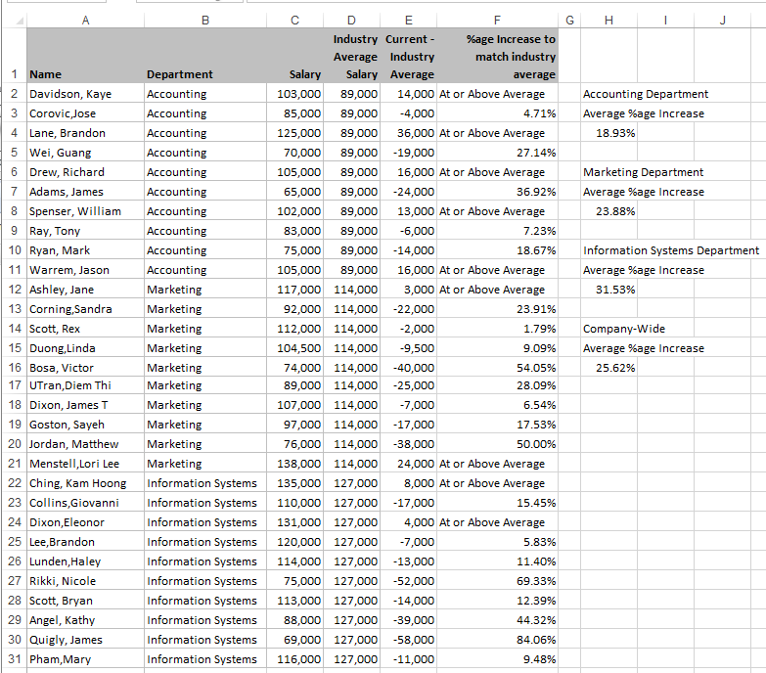

## How can you use this analysis to contribute to the employee salary decision? Based on this data, what conclusions can you make?

It may be valuable to know how our employee salaries compare with the average salaries in similar settings in our industry. Presumably, if our employee salaries are considerably lower than those across the industry, then we will be at risk of losing those employees to our competitors and we might experience high employee turnover. On the other hand, if our salaries are higher than industry averages for similar positions, then we should not expect high turnover and perhaps could lure some top candidates away from our competitors to join our organization.

The above spreadsheet shows that in the Accounting Department, five employees are earning salaries below the industry average; in Marketing, eight employees are earning salaries below the industry average; and in IS, eight employees are below the industry average.

Some care should be taken not to put too much weight on these averages, however. Averages can be distorted easily with just a few outlier values. A better comparison might be to median industry salaries. In addition, we should be sure that these comparisons are for similar firms of similar size in similar regions of the country. It is not meaningful to compare companies that are very different in terms of size or that are based in very different geographical settings, even though they are in the same industry. In addition, we have people within departments that are quite different in terms of skill, managerial level, experience, seniority, etc. Therefore, departmental industry averages cannot be meaningfully applied to every position within the department.

The industry average information provided in this problem illustrates information that may be accurate, has some relevance to the salary decision, but is not sufficient to fully inform the salary decision. (LO: 4, Learning Outcome: Explain how information systems can be used to assist in decision making, AACSB: Information Technology)

## Suppose other team members want to use your spreadsheet. Name three ways you can share it with them and describe the advantages and disadvantages of each.

The spreadsheet could be sent to each team member via email. This is simple and convenient, but there is no assurance that the attachment will actually be opened and read. In addition, there is no control over changes that might be made by the other team members. The spreadsheet could be sent to a shared file server so that all team members could access the file. This option is nice because there is a known location where the file is stored. However, there is no control over the content of the file and the changes that might be made by the team members. Another option is to use Google Drive or Microsoft OneDrive to make the file available to the team members. This system provides version management, so that changes made by team members are tracked and coordinated. (LO: 4, Learning Outcome: Explain how information systems can be used to assist in decision making, AACSB: Information Technology)

Chapter 7: Managerial Decision Making with Access

1. *Suppose you have been asked to assist in the managerial decision about how much to increase pay in the next year. Specifically, you are tasked to determine if there are significant salary differences among departments in your company.*

*You are given an Access database with a table of employee data with the following structure:*

## EMPLOYEE (Name, Department, Specialty, Salary)

*where* Name *is the name of an employee who works in a department,* Department *is the department name,* Specialty *is the name of the employee’s primary skill, and* Salary *is the employee’s current salary. Assume that no two employees have the same name. You have been asked to answer the following queries:*

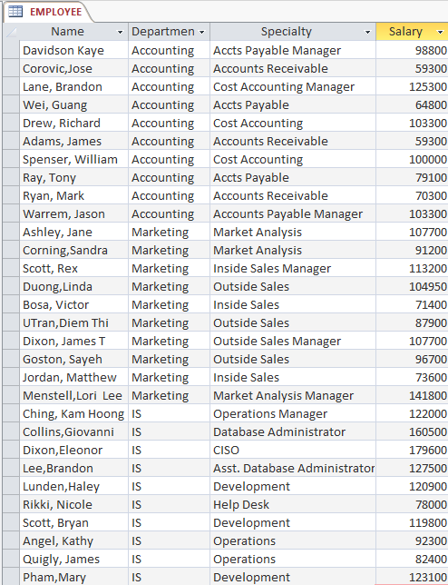

*(1) List the names, department and salary of all employees earning more than $100,000.*

*(2) List the names and specialties of all employees in the Marketing department.*

*(3) Compute the average, maximum, and minimum salary of employees in your company.*

*(4) Compute the average, minimum, and maximum salary of employees in the Marketing department.*

*(5) Compute the average, minimum, and maximum salary of employees in the Information Systems department.*

*(6)* Extra Credit: *Compute the average salary for employees in every department. Use* Group By.

## Design and run Access queries to obtain the answers to these questions, using the data in the Access file Ch07Ex02_E9e.accdb.

**Question 1:**

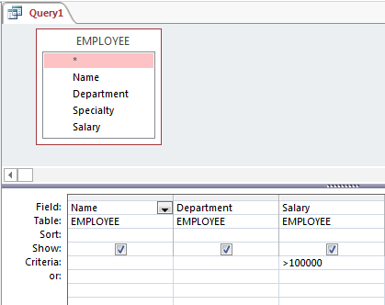

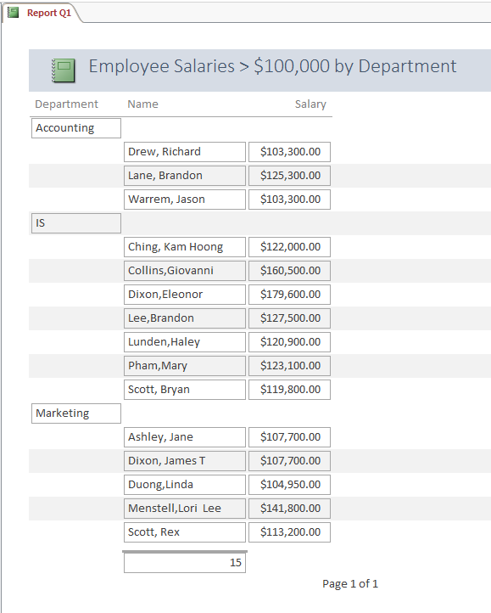

**Question 2:**

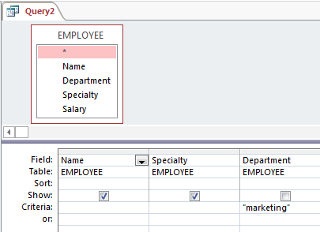

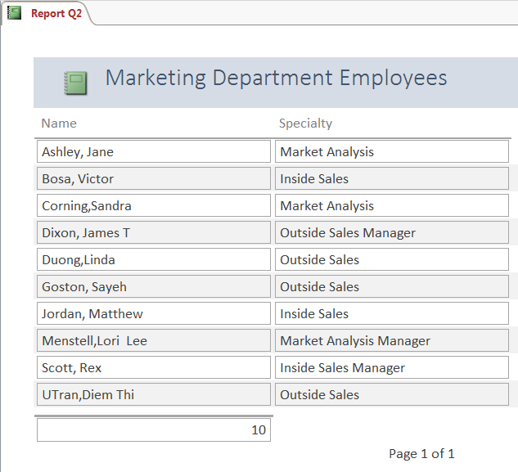

**Question 3:**

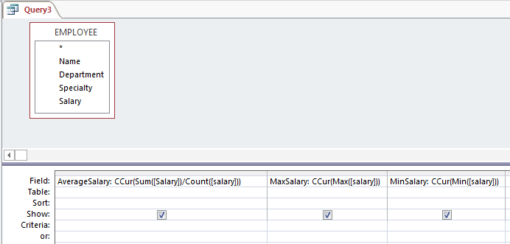

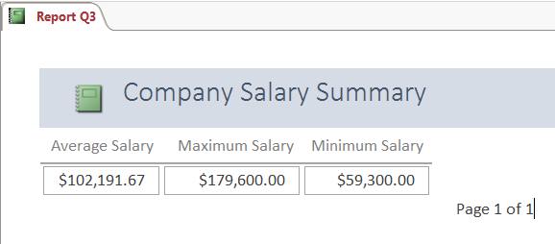

**Question 4:**

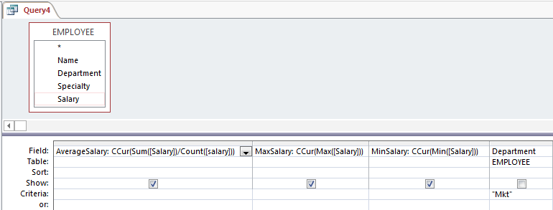

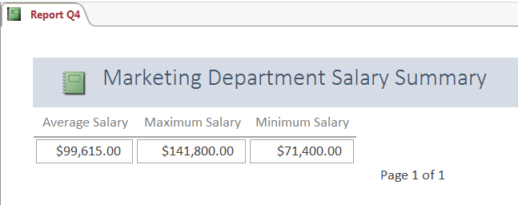

**Question 5:**

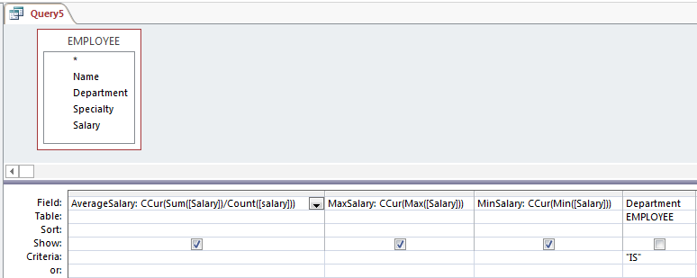

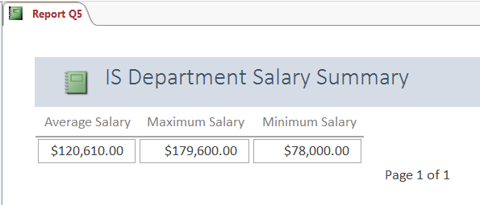

**Question 6 (Extra Credit):**

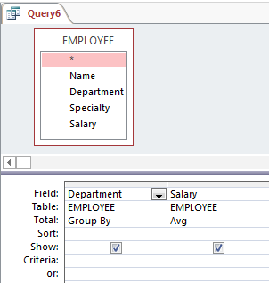

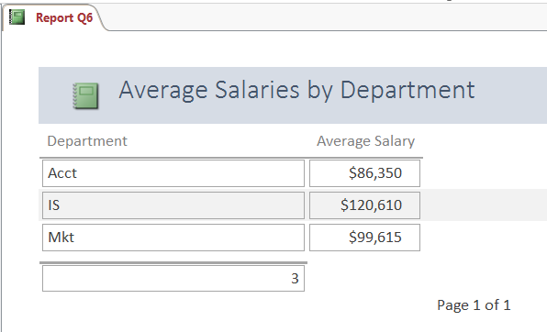

(LO: 4, Learning Outcome: Explain how information systems can be used to assist in decision making, AACSB: Information Technology)

## Explain how the data in your answer contributes to the salary increase decision.

The query-based reports shown above give a little more insight into salaries within the three departments. IS and Marketing have the highest average salaries. The range within each of these two departments is also shown. It is difficult, however, to assess whether these salaries are appropriate for our company without knowing more facts, such as average or median salary for similar job categories in our region. (LO: 4, Learning Outcome: Explain how information systems can be used to assist in decision making, AACSB: Information Technology)

## Suppose other team members want to use your Access application. Name three ways you can share it with them, and describe the advantages and disadvantages of each.

The database could be uploaded to a shared file server using ftp. With the database stored in a known, accessible location, all team members could use it. The problem with this approach is that if the team members wanted to modify the database, it is possible for them to interfere with each other’s work because there will be no version control. Another option is Microsoft OneDrive. The team members can be invited to a workspace where the database is stored, use it, and modify it with version management. A third option is to use Microsoft SharePoint. SharePoint can be used to give all team members access to the database, but can set access control so that only authorized users can make changes. SharePoint can also set a workflow with reminders to users to review the database in a timely way. The disadvantage of SharePoint is that it is a sophisticated software product that needs to be professionally administered. (LO: 4, Learning Outcome: Explain how information systems can be used to assist in decision making, AACSB: Information Technology)

Chapter 8: Production Planning with Excel

1. *Suppose your manager asks you to create a spreadsheet to compute a production schedule. Your schedule should stipulate a production quantity for seven products that is based on sales projections made by three regional managers at your company’s three sales regions.*

*a. Create a separate worksheet for each sales region. Use the data in the Word file* ***Ch08Ex01_E9e.docx****, which you can download from the text’s Web site. This file contains each manager’s monthly sales projections for the past year, actual sales results for those same months, and projections for sales for each month in the coming quarter.*



1. *Create a separate worksheet for each region’s data. Import the data from Word into Excel.*

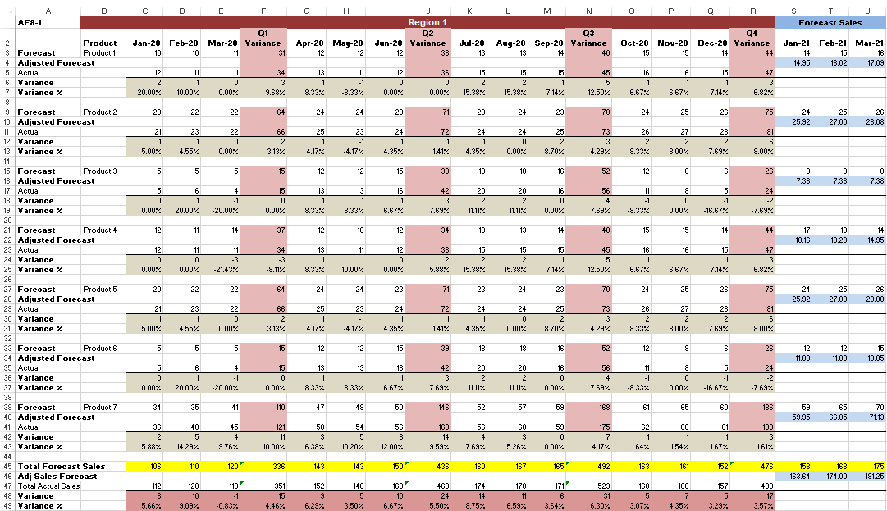

(Similar worksheets are created for Regions 2 and 3.)

(LO: 1, Learning Outcome: Discuss the role of information systems in supply chain management and performance, AACSB: Information Technology)

*c. On each of the worksheets, use the data from the prior four quarters to compute the discrepancy between the actual sales and the sales projections. This discrepancy can be computed in several ways: You could calculate an overall average, or you could calculate an average per quarter or per month. You could also weight recent discrepancies more heavily than earlier ones. Choose a method that you think is most appropriate. Explain why you chose the method you did.*

The worksheet above used an average discrepancy for the previous quarter. This assumption was used because the previous quarter’s results were considered to be the best predictor of the current quarter’s performance. (LO: 1, Learning Outcome: Discuss the role of information systems in supply chain management and performance, AACSB: Information Technology)

*d. Modify your worksheets to use the discrepancy factors to compute an adjusted forecast for the coming quarter. Thus, each of your spreadsheets will show the raw forecast and the adjusted forecast for each month in the coming quarter.*

This information is shown in the right-most three columns in the part b worksheets. (LO: 1, Learning Outcome: Discuss the role of information systems in supply chain management and performance, AACSB: Information Technology)

*e. Create a fourth worksheet that totals sales projections for all of the regions. Show both the unadjusted forecast and the adjusted forecast for each region and for the company overall. Show month and quarter totals.*

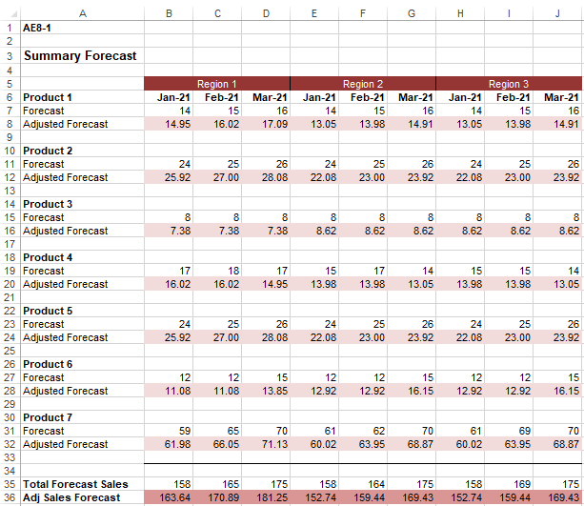

(LO: 1, Learning Outcome: Discuss the role of information systems in supply chain management and performance, AACSB: Information Technology)

*f. Create a bar graph showing total monthly production. Display the unadjusted and adjusted forecasts using different colored bars.*

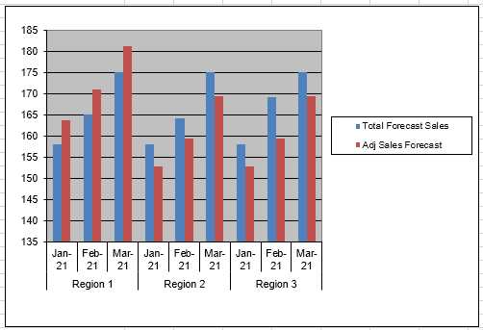

(LO: 1, Learning Outcome: Discuss the role of information systems in supply chain management and performance, AACSB: Information Technology)

Chapter 8: Managing Materials with Access

*AE8-2. Figure AE-6 is a sample bill of materials(BOM), a form that shows the components and parts used to construct a product. In this example, the product is a child’s wagon. Such bills of materials are an essential part of manufacturing functional applications as well as ERP applications.*

*This particular example is a form produced using Microsoft Access. Creating such a form is a bit tricky, so this exercise will guide you through the steps required. You can then apply what you learn to produce a similar report. You can also use Access to experiment on extensions of this form.*

*a. Create a table named* PART *with columns* PartNumber, Level, Description, QuantityRequired, *and* PartOf. Description *and* Level *should be text,* PartNumber *should be* AutoNumber, *and* QuantityRequired *and* PartOf *should be numeric, long integer. Add the* PART *data in Figure AE-8 to your table.*

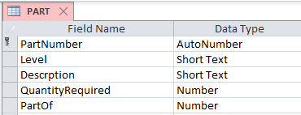

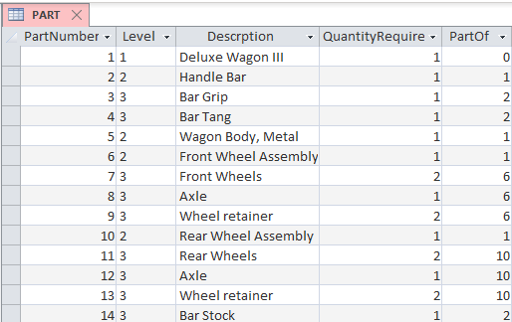

(LO: 5, Learning Outcome: Discuss the role of information systems in supporting business processes, AACSB: Information Technology)

*b. Create a query that has all columns of* PART. *Restrict the view to rows having a value of 1 for* Level. *Name your query* Level1.

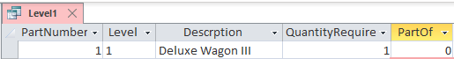

(LO: 5, Learning Outcome: Discuss the role of information systems in supporting business processes, AACSB: Information Technology)

*c.* Create two more queries that are restricted to rows having values of 2 or 3 forLevel. *Name your queries* Level2 *and* Level3*, respectively.*

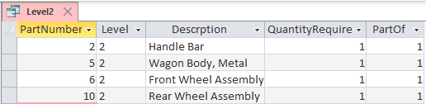

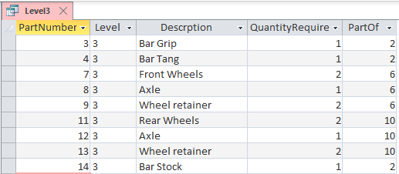

(LO: 5, Learning Outcome: Discuss the role of information systems in supporting business processes, AACSB: Information Technology)

*d. Create a form that contains* PartNumber, Level, *and* Description *from* Level1. *You can use a wizard for this if you want. Name the form* Bill of Materials.

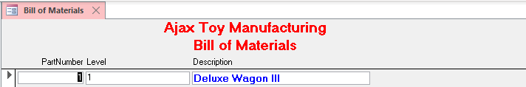

(LO: 5, Learning Outcome: Discuss the role of information systems in supporting business processes, AACSB: Information Technology)

*e. Select the Subform/Subreport tool in the Controls section of the DESIGN ribbon and create a subform in your form in part d. Set the data on this form to be all of the columns of* Level2*. After you have created the subform, ensure that the Link Child Fields property is set to* PartOf *and that the Link Master Fields property is set to* PartNumber. *Close the* Bill of Materials *form.*

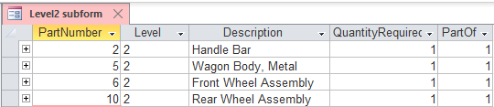

(LO: 5, Learning Outcome: Discuss the role of information systems in supporting business processes, AACSB: Information Technology)

*f. Open the subform created in part e and create a subform on it using the Subform/Subreport control. Set the data on this subform to be all of the columns of* Level3*. After you have created the subform, ensure that the Link Child Fields property is set to* PartOf *and that the Link Master Fields property is set to* PartNumber. *Close the* Bill of Materials *form.*

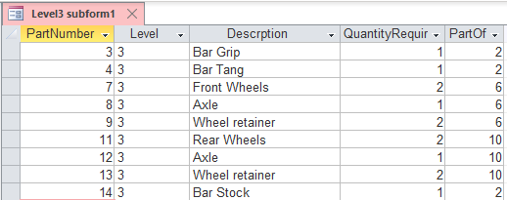

(LO: 5, Learning Outcome: Discuss the role of information systems in supporting business processes, AACSB: Information Technology)

*g. Open the* Bill of Materials *form. It should appear as in Figure AE-6. Open and close the form and add new data. Using this form, add sample BOM data for a product of your own choosing.*

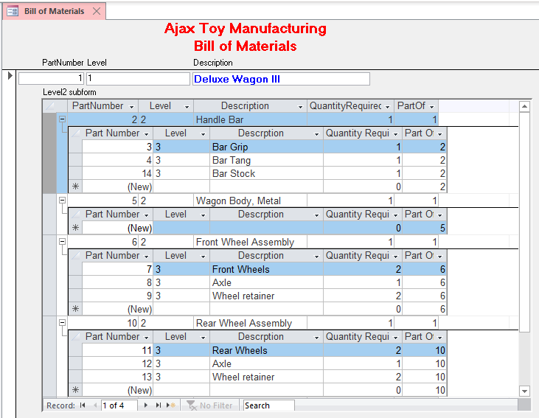

(LO: 5, Learning Outcome: Discuss the role of information systems in supporting business processes, AACSB: Information Technology)

*h. Following the process similar to that just described, create a* Bill of MaterialsReport *that lists the data for all of your products.*

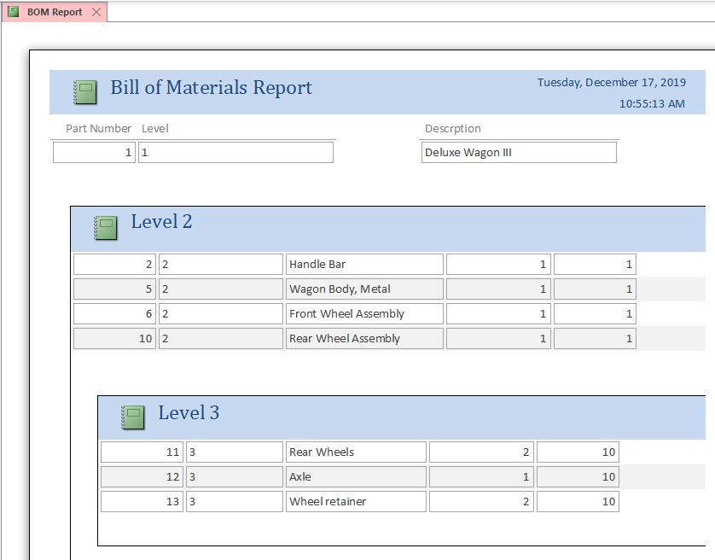

(Partial report)

(LO: 5, Learning Outcome: Discuss the role of information systems in supporting business processes, AACSB: Information Technology)

*i.* **(Optional, challenging extension)** *Each part in the BOM in Figure AE-6 can be used in at most one assembly (there is space to show just one* PartOf *value). You can change your design to allow a part to be used in more than one assembly as follows. First, remove* PartOf *from PART. Next, create a second table that has two columns:* AssemblyPartNumber *and* ComponentPartNumber. *The first contains a part number of an assembly, and the second contains a part number of a component. Every component of a part will have a row in this table. Extend the views described above to use this second table and to produce a display similar to Figure AE-6.*

The trick is setting up the queries at each level to include the proper keys, and then using those keys in the Link Master and Link Child properties of the subform controls. The tables, queries, and form for this version follow.

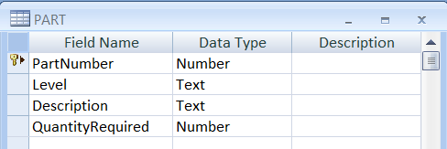

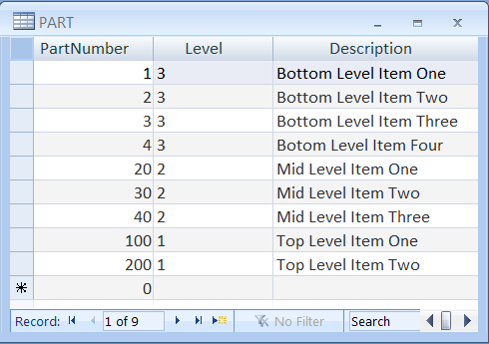

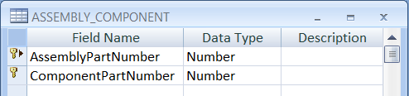

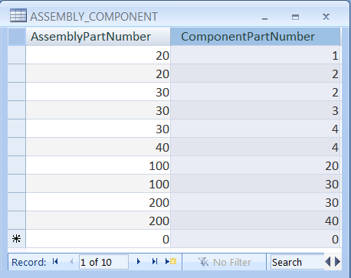

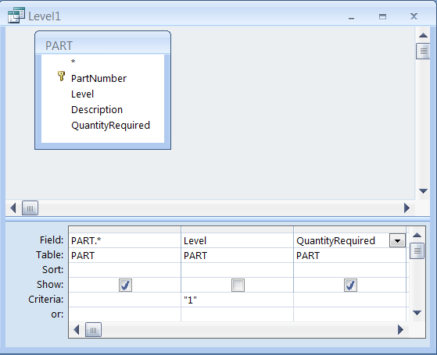

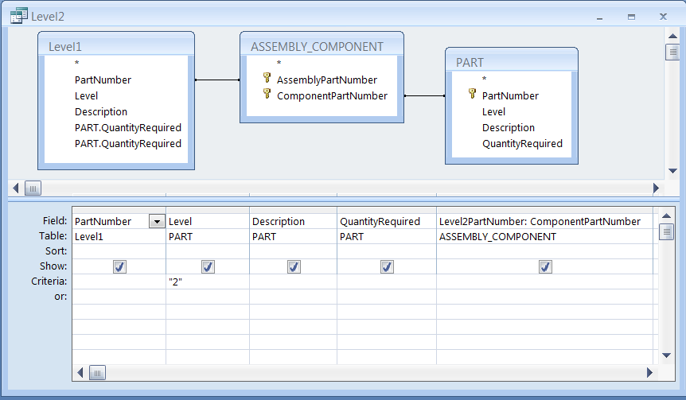

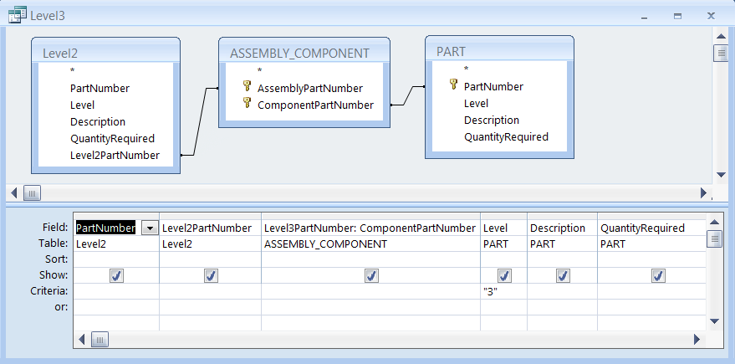

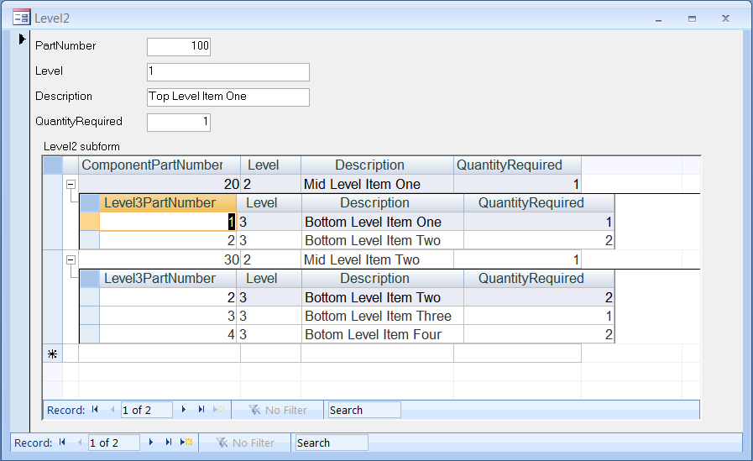

(LO: 5, Learning Outcome: Discuss the role of information systems in supporting business processes, AACSB: Information Technology)

 Chapter 9: Tracking Social Media

1. *Suppose you are the manager of social media policy for an organization having 1,000 employees with seven different offices throughout North America. Further suppose that the CEO has requested a report showing a list of all of the employees’ blogs, the employees’ job titles and departments, and the purpose and URL of each blog. She doesn’t want to control employees; she just wants to know where they are.*
2. *Explain the conditions under which using a spreadsheet to track this data would be appropriate.*

A spreadsheet would be appropriate if the data was expected to remain very stable. Employees would not change job titles or departments and the blogs that are tracked for each employee do not change. Since these conditions are unlikely, the spreadsheet is not the best choice for this purpose. (LO: 2, Learning Outcome: Discuss the role of information systems in supporting business processes, AACSB: Information Technology)

1. *Suppose that employees can have more than one blog but that a blog is only supported by a single employee. Further suppose you decide that you need to track the dates on which a blog was first created and the date of the last posting if the blog is no longer active. Design a database for these requirements.*

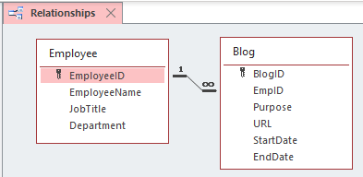

(LO: 2, Learning Outcome: Discuss the role of information systems in supporting business processes, AACSB: Information Technology)

1. *Fill your database with the sample data in the Word document* ***Ch09Ex01_E9e.docx****. EmployeeID is a unique identifier; a null value for EndDate means the blog is still active. Do not retype this data; import it instead. You can either import it several times, each time to a different table, or you can import it once and use queries to fill the tables.*

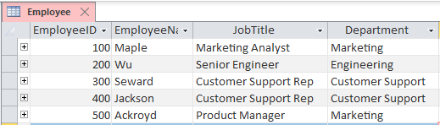

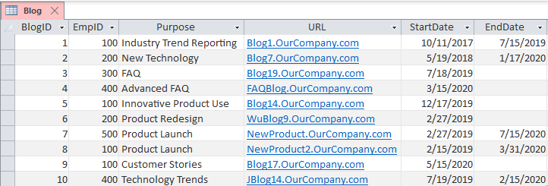

(LO: 2, Learning Outcome: Discuss the role of information systems in supporting business processes, AACSB: Information Technology)

1. *Create a report that is suitable for the CEO’s needs. Justify the content and structure of your report.*

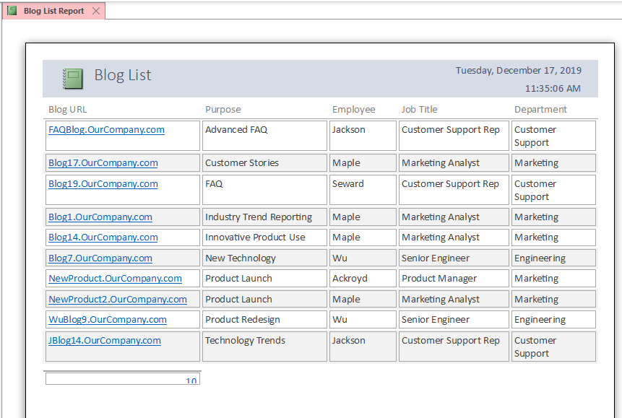

Students answers will vary. The report example above lists the blogs organized by blog purpose. This organization will give the CEO a quick view of how the organization is using blogs. (LO: 2, Learning Outcome: Discuss the role of information systems in supporting business processes, AACSB: Information Technology)

Chapter Extension 10: Google Drive

1. *This exercise requires you to experiment with Google Drive. You will need two Google accounts to complete this exercise.*

*a. In a memo, explain the role of communication in collaboration. Go to* <http://drive.google.com>/ *and sign in with one of your Google accounts. Upload your memo using Google Drive. Save your uploaded document and share it with the email in your second Google account. Sign out of your first Google account.*

*(If you have access to two computers situated close to each other, use both of them for this exercise. You will see more of the Google Drive functionality by using two computers. If you have two computers, do not sign out of your Google account. Perform step b and all actions for the second account on that second computer. If you are using two computers, ignore the instructions in the following steps to sign out of the Google accounts.)*

*b. Open a new window in your browser. Access* <http://drive.google.com>/ *from that second window, and sign in using your second Google account. Open the document that you shared in step a.*

*c. Change the memo by adding a brief description of the need to manage the content in many collaboration projects. Save the document from your second account. If you are using just one computer, sign out from your second account.*

*d. Sign in on your first account. Open the most recent version of the memo and add a description of the role of version histories. Save the document. (If you are using two computers, notice how Google warns you that another user is editing the document at the same time. Click* Refresh *to see what happens.) If you are using just one computer, sign out from your first account.*

*e. Sign in on your second account. Reopen the shared document. From the File menu, save the document as a Word document. Describe how Google processed the changes to your document*

Since this is an experiential exercise, no specific solution is provided. (LO: 3, Learning Outcome: Explain how IS can enhance systems of collaboration and teamwork, AACSB: Information Technology)

Chapter Extension 10: Microsoft OneDrive

1. *This exercise requires you to experiment with Microsoft OneDrive. You will need two Office Live IDs to complete this exercise. The easiest way to do this is to work with a classmate. If that is not possible, set up two Office Live accounts, using two different Hotmail addresses.*

*a. Go to* [www.onedrive.com](http://www.onedrive.com), *and sign in with one of your accounts. Create a memo about collaboration tools using the Word Web App. Save your memo. Share your document with the email in your second Office Live account. Sign out of your first account.*

*(If you have access to two computers situated close to each other, use both of them for this exercise. If you have two computers, do not sign out of your Office Live account. Perform step b and all actions for the second account on that second computer. If you are using two computers, ignore the instructions in the following steps to sign out of the Office Live accounts.)*

*b. Open a new window in your browser. Access* [www.onedrive.com](http://www.onedrive.com) *from that second window, and sign in using your second Office Live account. Open the document that you shared in step a.*

*c. Change the memo by adding a brief description of content management. Do not save the document yet. If you are using just one computer, sign out from your second account.*

*d. Sign in on your first account. Attempt to open the memo and note what occurs. Sign out of your first account, and sign back in with your second account. Save the document. Now, sign out of your second account, and sign back in with the first account. Now attempt to open the memo. (If you are using two computers, perform these same actions on the two different computers.)*

*e. Sign in on your second account. Reopen the shared document. From the File menu, save the document as a Word document. Describe how OneDrive processed the changes to your document.*

Since this is an experiential exercise, no specific solution is provided. (LO: 3, Learning Outcome: Explain how IS can enhance systems of collaboration and teamwork, AACSB: Information Technology)

Chapter Extension 13: Evaluate Vendors with Access

1. *Assume you have been given the task of compiling evaluations of vendors made by your company’s purchasing agents. Each month, every purchasing agent evaluates all of the vendors that he or she has worked with in the past month on three factors: price, quality, and responsiveness. Assume the ratings are from 1 to 5, with 5 being the best. Because your company has hundreds of vendors and dozens of purchasing agents, you decide to use Access to compile the results.*

*a. Create a database with three tables: VENDOR* (VendorNumber, Name, Contact), *PURCHASER* (EmpNumber, Name, Email), *and RATING* (EmpNumber, VendorNumber, Month, Year, PriceRating, QualityRating, ResponsivenessRating)*. Assume that* VendorNumber *and* EmpNumber *are the keys of VENDOR and PURCHASER, respectively. Decide what you think is the appropriate key for RATING.*

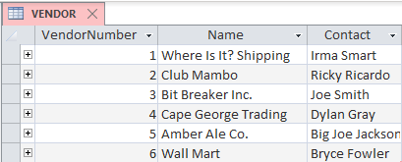

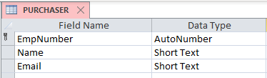

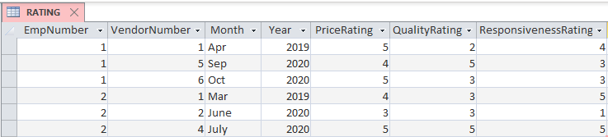

*b. Create appropriate relationships.*

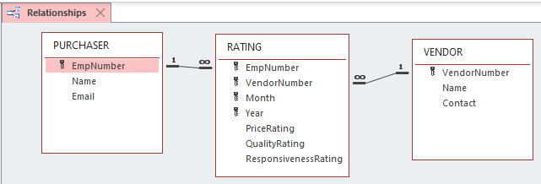

*c. Go to this text’s companion Web site and import the data in the Excel file* ***CE13Ex01_E9e.xlsx****. Note that data for VENDOR, PURCHASER, and RATING are stored in three separate worksheets.*

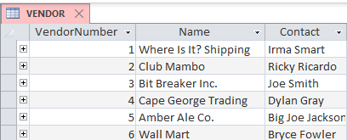

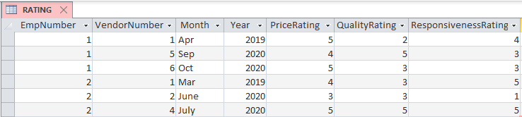

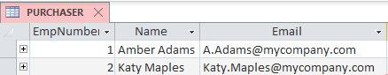

*d. Create a query that shows the names of all vendors and their average scores.*

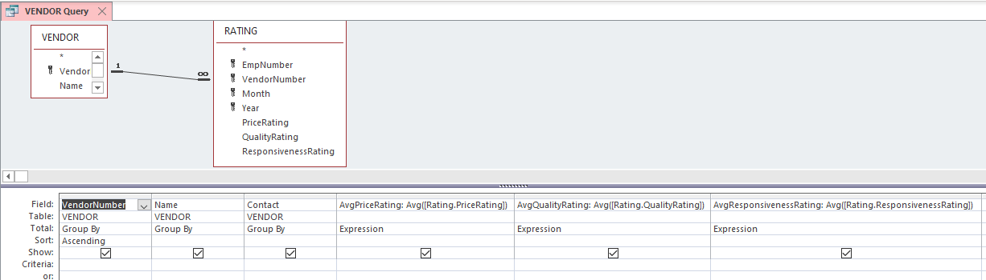

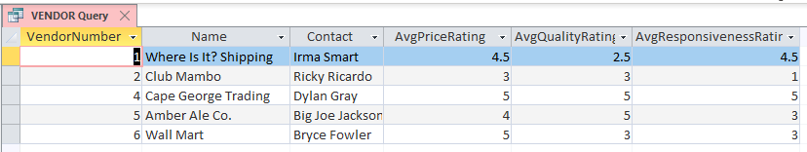

*e. Create a query that shows the names of all employees and their average scores.* Hint: *In this and in part f, you will need to use the* Group By *function in your query.*

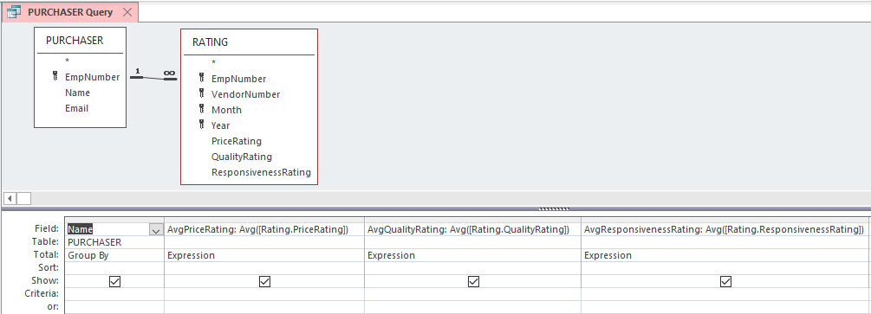

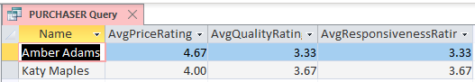

*f. Create a parameterized query that you can use to obtain the minimum, maximum, and average ratings on each criterion for a particular vendor. Assume you will enter* VendorName *as the parameter.*

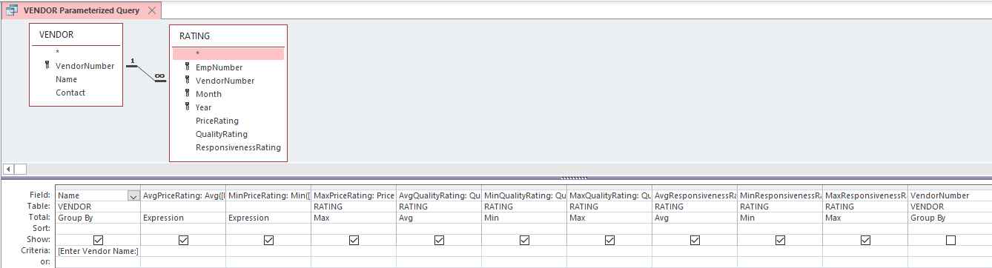



1. *Using the information created by your queries, what conclusions can you make about vendors or purchasers?*

Cape George Trading received an average rating of 5 on all three dimensions, indicating that our purchasing agents think this vendor is superior on price, quality, and responsiveness. Where Is It? Shipping is considered very good on price and responsiveness but has a rather low average quality rating. The poorest vendor appears to be Club Mambo. The other vendors received a mix of high and moderate ratings from the purchasing agents. The information about the purchasing agents does not lend itself to many conclusions, other than Amber Adams gave the highest average rating on price, but the lowest average rating on quality and responsiveness.

(LO: 3, Learning Outcome: Explain how information systems can be used to assist in decision making, AACSB: Information Technology)

PART 4

Chapter 10: Enabling Secure Browsing

1. *Adblock Plus® is a Web browser add-on that can block advertisements. It can also block trackers and domains that are known sources of malware. In addition, it allows you to create custom filters that can block specific Web content. Adblock Plus can make Web surfing safer and more enjoyable by eliminating annoying ads.*

*In this project, you will compare the same Web site in two browsers. You will install Adblock Plus in Firefox. You’ll then compare the filtered Web site to an unfiltered version in Google Chrome.*

1. *Open Google Chrome and browse to* [www.amazon.com](http://www.amazon.com)*.*
2. *Fill the right-hand side of your screen with your Google Chrome browser by pressing the Window key and right arrow.*
3. *Open Firefox and browse to* [www.amazon.com](http://www.amazon.com)*.*
4. *Fill the left-hand side of your screen with your Firefox browser by pressing the Window key and left arrow. You should now have two browsers displaying side by side.*
5. *In your Firefox browser, type your name into the Amazon search box, but don’t press Enter.*
6. *Take a screenshot. (You can take a screenshot of your entire desktop by pressing Ctrl+PrintScreen).*
7. *Click the Firefox menu, and then click Add-ons.*
8. *Click Get Add-ons.*
9. *In the search box, enter “Adblock Plus.”*
10. *Press Enter.*
11. *Click Install for the latest version of Adblock Plus.*
12. *Click Restart now.*
13. *Refresh the Amazon Web page in your Firefox browser. (You can press F5 or the Refresh button.)*
14. *Enter your name in the Amazon search bar in your Firefox browser, but don’t press Enter. (Note the reduced number of trackers and ads along the right-hand side when compared to the exact same page in your Google Chrome browser.)*
15. *Take a screenshot of your entire desktop.*
16. *Select another Web site that you know has advertising and visit it in both browsers. (Major news Web sites typically have lots of ads and trackers.)*
17. *Take another screenshot of your entire desktop, showing the difference in browsers.*
18. *Would online retailers dislike Adblock Plus? Why or why not?*
19. *Some Web sites pay for their operations through ad revenue. Could Adblock Plus put them out of business?*
20. *Can you make exceptions (i.e., not block content) for specific Web sites?*

(LO: 5, Learning Outcome: Describe different methods of managing IS security, AACSB: Information Technology)

Chapter 10: Safe Web Browsing

1. *Most users want an easy way to identify which Web sites are trustworthy and which Web sites they should avoid. Web of Trust® (WOT) provides a “scorecard” for each Web site you visit. This scorecard gives you a summary of four ratings: trustworthiness, vendor reliability, privacy, and child safety. The values shown on the scorecard are based on ratings from members of the WOT community who have contributed their evaluations of that Web site.*

*After installing WOT, you will notice a slight addition to the search results from major search engines (e.g., Google, Bing, and Yahoo!). You will see a WOT evaluation at the end of each search result. This evaluation provides a scorecard for each Web site displayed in the search results. The WOT evaluation can serve as a quick visual indicator of Web sites to avoid.*

1. *Open Firefox, click the Firefox menu, and click Add-ons.*

No specific answer—a task to be performed.

1. *Search for “WOT”.*

No specific answer—a task to be performed.

1. *Click Install (WOT) and Restart now. (You should see a small flag in the navigation bar.)*

No specific answer—a task to be performed.

1. *Browse to* www.google.com *and search for your full name.*

No specific answer—a task to be performed.

1. *Take a screenshot of the results and paste it into your document. (You can take a screenshot by pressing Alt+Print Screen. Notice the WOT icons next to each of the search results.)*

No specific answer—a task to be performed.

1. *Click on the WOT icon for one of the search results. (This will show you the WOT scorecard for that specific Web site.)*

No specific answer—a task to be performed.

1. *Using Google, search for* warez keygen*. (You should get a few Web sites with red circles, meaning they have a poor reputation.)*

No specific answer—a task to be performed.

1. *Click on the WOT icon for WOT scorecard of one of the Web sites with a red circle.*

No specific answer—a task to be performed.

1. *Take a screenshot and paste it into your document.*

No specific answer—a task to be performed.

1. *Describe how WOT gets the values for its Web site scorecards.*

Ratings come from the user community, who provide ratings for sites based on their own experiences with the site.

1. *Describe how you can evaluate Web sites using WOT.*

The colored icon indicates the site’s reputation based on the user community’s ratings.

1. *Explain how WOT can protect users when they are surfing the Internet.*

If a user browses to a Web site and the rating symbol indicates a questionable reputation, the user has the option of leaving the site rather than blindly going in without knowledge of the site’s reputation. (LO: 5, Learning Outcome: Describe different methods of managing IS security, AACSB: Information Technology)

Chapter 10: File Recovery

*AE10-3. Recuva® is a program by Piriform® that recovers previously deleted files. Recuva scans the entire empty memory space for possible files to recover. Most users erroneously believe that data is gone forever when they empty it from the Recycle Bin. This is incorrect. It merely marks the space as available to be written over if another file needs to be stored. Your operating system writes over these available spaces and subsequently “damages” the previously deleted file. Recovery software can easily recover the undamaged part of the file if it knows how the file is structured.*

*In this project you will recover a file you delete from your USB drive. You can also run Recuva on your main hard drive if you accidently lose an important file.*

*a. Download and install Recuva from* www.cleaner.com/recuva/download*.*

*b. If the program doesn’t automatically open, you can click on the newly-created desktop icon or click Start and search for Recuva.*

*c. Insert a USB drive into your computer.*

*d. Select your USB drive as the drive from which you want to recover files. (You can always scan your C: drive. Your USB will finish much quicker than your C: drive.)*

*e. Click* Scan*.*

*f. After the scan completes, click on any of the recovered files listed with a graphic extension (e.g., .jpg or .bmp) until you see a picture on the right-hand side of the screen. (If you don’t see an image file, you can put a file on your USB, delete it, and then run the scan again. Remember the name of the file you delete, so you can easily find it after you recover it.)*

*g. Click on the Info tab to see the details for the file and take a screenshot.*

*h. Check one of the recoverable graphic files. (Even some of the “unrecoverable” files are actually recoverable.)*

*i. Click Recover and save it to your desktop.*

*j. Open the picture you recovered, and take a screenshot.*

*k. Would Recuva work on your cell phone if it were connected to your computer?*

*l. What effect does the condition of the file have on its ability to be recovered?*

No specific answers – tasks to be performed by the student. (LO: 5, Learning Outcome: Describe different methods of managing IS security, AACSB: Information Technology)

Chapter 11: Keeping Track of Requests

*AE11-1. Suppose you have just been appointed manager of a help desk with an IS department. You have been there for just a week, and you are amazed to find only limited data to help you manage your employees. In fact, the only data kept concerns the processing of particular issues, called Tickets. The following data are kept:* Ticket#*,* Date_Submitted*,* Date_Opened*,* Date_Closed*,* Type (new or repeat)*,* Reporting_ Employee_Name*,* Reporting_Employee_ Division*,* Technician_Name*_*Problem_System*, and* Problem_Description*. You can find sample Ticket data in the Excel file* ***Ch11Ex01_E9e.xlsx****.*

*As a manager, you need information that will help you manage. Specifically, you need information that will help you learn who are your best- and worst-performing technicians, how different systems compare in terms of number of problems reported and the time required to fix those problems, how different divisions compare in terms of problems reported and the time required to fix them, which technicians are the best and worst at solving problems with particular systems, and which technicians are best and worst at solving problems from particular divisions.*

1. *Use either Access or Excel, or a combination of the two, to produce the information you need using the data in the Excel file* ***Ch11Ex01_E9e.xlsx****. In your answer, you may use queries, formulas, reports, forms, graphs, pivot tables, pivot charts, or any other type of Access or Excel display. Choose the best display for the type of information you are producing.*

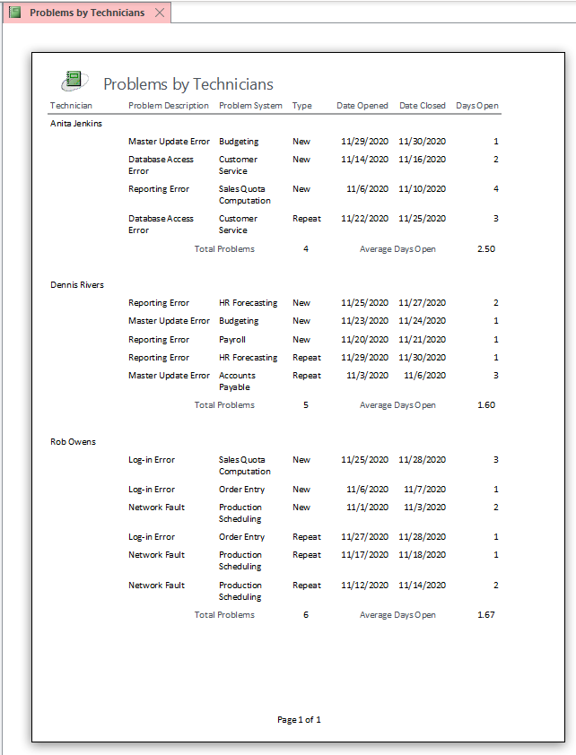

The above sample report shows the type of information that can be developed if the raw data is inserted into a database. This report has been grouped by technician and sorted by problem type. A count of the number of problems handled per technician was inserted in the report. In addition, the duration of each problem ticket was computed and the average problem duration was computed.

Similar reports could be created grouped by problem system, by problem description, and problem type. (LO: 1, Learning Outcome: Discuss best practices for selecting, evaluating, and managing information systems projects, AACSB: Information Technology)

*b. Explain how you would use these different types of information to manage your department.*

The sample report included above would help the manager look for *differences that make a difference*. For example, the report shows that Susan Jenkins has handled the fewest number of problems during the month and has the longest average duration. Is this fact attributable to skills that need upgrading, or due to the fact that these problems are more complex that those assigned, say, to Rob Owens? (LO: 1, Learning Outcome: Discuss best practices for selecting, evaluating, and managing information systems projects, AACSB: Information Technology)

*c. Specify any additional information that you would like to have produced from this data to help you manage your department.*

Students’ ideas will vary. One item that would have been helpful would have been the technician’s entry of what was done to resolve the problem, so that fixes that were ineffective could be identified and more effective fixes could be developed. (LO: 1, Learning Outcome: Discuss best practices for selecting, evaluating, and managing information systems projects, AACSB: Information Technology)

*d. Use either Access or Excel, or a combination, to produce the information in part c.*

Student answers will vary depending on the answer to part c. (LO: 1, Learning Outcome: Discuss best practices for selecting, evaluating, and managing information systems projects, AACSB: Information Technology)

**Chapter 12: Planning Project Costs With Excel

1. *Suppose you are given the task of comparing labor costs of meetings for systems development projects to budgets. Download the Word file* ***Ch12Ex01_E9e.docx*** *and the Excel file with the same name. The Word file has records of meeting dates, times, and attendees. The document was created from informal notes taken at the meetings. The Excel file has the project budgets as well as labor costs for different categories of employees.*

*Assume your company uses the traditional SDLC and each step requires two types of meetings: working and review.* Working meetings *involve users, business analysts, systems analysts, programmers, and PQA test engineers.* Review meetings *involve all of those people, plus level-1 and level-2 managers of both user departments and the IS department.*

1. *Using either Access or Excel, whichever you think is better suited to the task, import the Word data to a work file and compute the total labor for each type of employee for each meeting.*

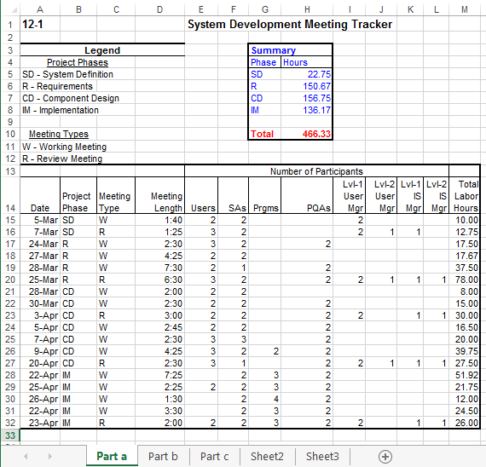

(LO: 5, Learning Outcome: Explain how information systems can be used to assist in decision making, AACSB: Information Technology)

1. *Using the file you created in part a, compute the total labor for each type of employee for each phase of the project.*

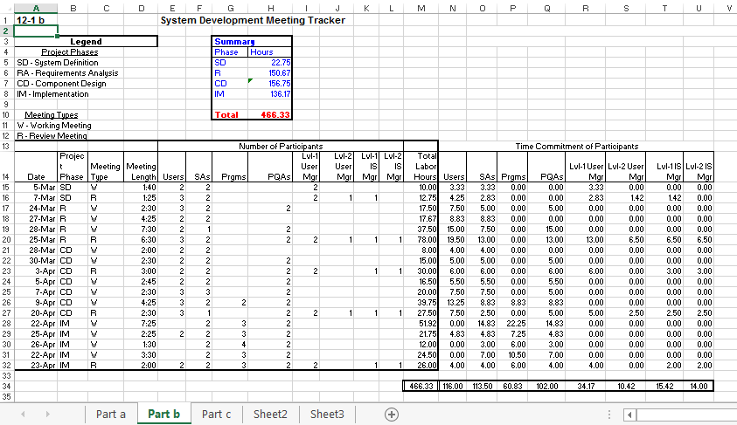

(LO: 5, Learning Outcome: Explain how information systems can be used to assist in decision making, AACSB: Information Technology)

1. *Combine your answer in part b with the data in the Excel file* ***Ch12Ex01_E9e.xlsx*** *to compute the total cost of meetings of each phase of the project.*

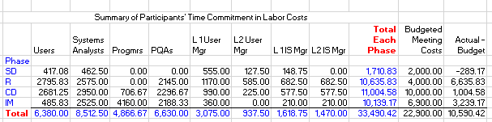

(LO: 5, Learning Outcome: Explain how information systems can be used to assist in decision making, AACSB: Information Technology)

1. *Use a graphic chart of the type you think best to show the differences from meeting cost and budget.*

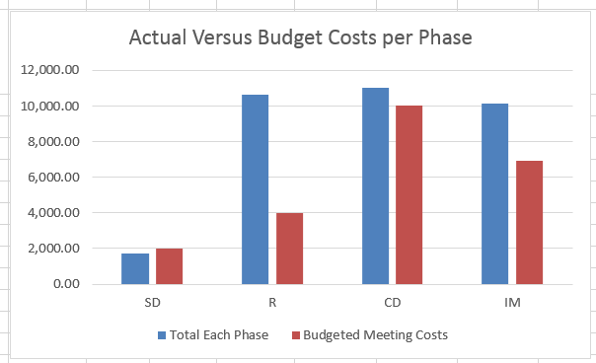

(LO: 5, Learning Outcome: Explain how information systems can be used to assist in decision making, AACSB: Information Technology)

1. *Comment on your choice of Excel or Access for your work file. If you were to do this exercise over, would you use that same tool again? Why or why not?*

I chose to use Excel for this problem. It is ideally suited to calculation-oriented situations such as this. I would use it again rather than use Access because of the ease of setting up the necessary calculations and the graphing capability. (LO: 5, Learning Outcome: Explain how information systems can be used to assist in decision making, AACSB: Information Technology)

Chapter 12: Developing a Game

1. *In this project you are going to use Microsoft MakeCode to create a very simple game called Chase the Pizza. Microsoft MakeCode allows you to create apps by dragging and dropping computer code “pieces” and making simple modifications. For this project, you are going to follow an automated tutorial that will guide you through the entire process. You don’t have to have any prior coding (programming) experience. Automated videos will introduce you to a few basic principles of coding and explain how your changes will affect your app.*

*The instructions below take you to the MakeCode Web site. From there you will follow an automated tutorial that will walk you through each step. The last step in this project asks you to take a screenshot of your app. You will then send this screenshot to your instructor verifying that you successfully completed this project.*

***(1)*** *Open a Web browser (e.g., Google Chrome or Mozilla Firefox) and go to* https://arcade.makecode.com*.*

***(2)*** *Click on tutorial named Chase the Pizza.*

***(3)*** *Click Start Tutorial*

***(4)*** *Click Ok on the introduction screen explaining what your game will do.*

***(5)*** *Follow the tutorial and drag-and-drop pieces from the left-hand menu onto the workspace.*

*If you get stuck, you can click the purple help button at the top of the page. After you complete each step click the Next button at the top right-hand of your screen.*

***(6)*** *Complete all 13 steps.*

***(7)*** *After finishing the tutorial, take a screenshot of your new app and paste it into a document. (You will send this document to your instructor. You can take a screenshot by selecting the window and then pressing Alt + Print Screen. Then you can paste the screenshot into your document.)*

***a.*** *Why was the order of the pieces important?*

***b.*** *Why are there different types of sprites?*

***c.*** *What would be the benefit of making a game easier for users to play? Could it be too easy or too hard?*

Since this is an experiential exercise, no specific solution is provided. Student answers will vary. (LO: 7, Learning Outcome: Compare and contrast different methods for developing information systems, AACSB: Information Technology)

 Chapter Extension 18: Process Modeling with Visio

1. *In this exercise, you will use Visio to create process diagrams in BPMN notation.*
2. *Download the Visio File* ***CE18Ex01_E9e.vsdx*** *from this text’s support site. Open the file and familiarize yourself with this diagram. Explain the major differences between the process documented in this file and that in Figure CE18-1.*

No specific answer—a task to be performed. (LO: 3, Learning Outcome: Discuss the role of information systems in supporting business processes, AACSB: Information Technology)

1. *Notice that Visio includes the BPMN shapes. Go to the Shape organizer to see other types of flowchart shapes that Visio supports.*

No specific answer—a task to be performed. (LO: 3, Learning Outcome: Discuss the role of information systems in supporting business processes, AACSB: Information Technology)

1. *Create a new Visio diagram. Add BPMN shapes that you may want to use.*

No specific answer—a task to be performed. (LO: 3, Learning Outcome: Discuss the role of information systems in supporting business processes, AACSB: Information Technology)

1. *Model the customer process Respond to Quotation. Make sure your process accepts the inputs shown in* ***CE18Ex01_E9e.vsdx*** *and produces the outputs shown in that figure. Create your process so that your company checks prices and delivery dates and requests changes, if appropriate. Include other logic, if necessary.*

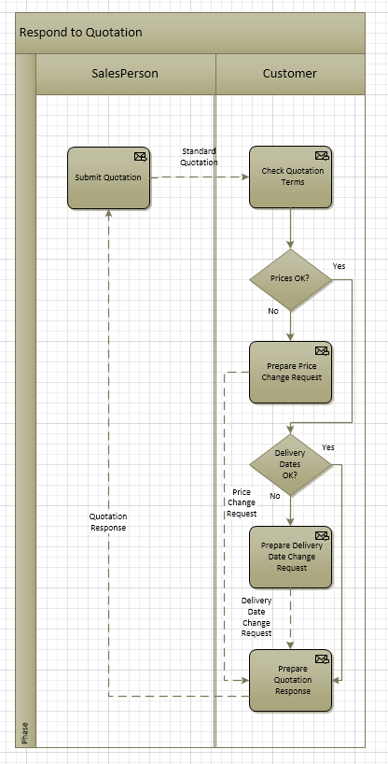

(LO: 3, Learning Outcome: Discuss the role of information systems in supporting business processes, AACSB: Information Technology)

1. *Show your work by saving your document as a PDF file.*

No specific answer—a task to be performed.

(LO: 3, Learning Outcome: Discuss the role of information systems in supporting business processes, AACSB: Information Technology)